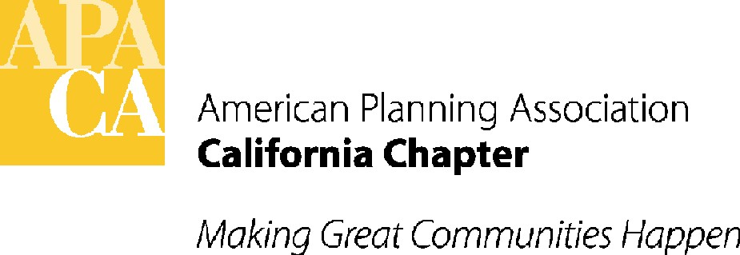

Governor's Releases 2014-2015 Budget Including Allocations Related to Planning and Economic Development Options

This morning, the Governor released his 2014-2015 state budget. There were a number of programs in the new budget that will impact planning. Below is the link to the Budget Summary and a list of planning-related budget items included in the Budget Summary, by page number, for your reference.

http://www.ebudget.ca.gov/FullBudgetSummary.pdf

2014-2015 BUDGET ITEMS RELATED TO PLANNING – BY PAGE NUMBER

Page 8 – Surplus: Projects about a $4 billion surplus.

Page 96 – Transportation Infrastructure Priorities: Discusses the transportation infrastructure workgroup that met last year, which will continue to meet this year, to prioritize transportation expenditures. The Governor recommends focusing on 3 areas resulting from that workgroup this year: maintaining existing transportation infrastructure, modernizing rail, and supporting local government efforts to implement SB 375 and sustainable communities strategies (SCSs). Future workgroup priorities will focus on implementations of reforms, many of which will be outlined in an upcoming external review of the Department Of Finance; implementation of goods-movement strategies, which are being developed through separate state and federal panels; and long-term stable transportation revenues to address declining revenues from fuel excise taxes.

Page 97 – Cap and Trade Fund Allocations: Includes $300 million in new funding for rail modernization, including $50 million for Caltrans to fund competitive grants for existing rail operators to integrate rail systems and to provide connectivity to high-speed rail and $250 million for the High Speed Rail Authority to fund start of construction; $100 million for the Strategic Growth Council for investments to support SB 375 projects including transit and transit-oriented development, low-income housing, active transportation projects, environmental mitigation and agricultural land preservation, and related planning.

Page 98 – Appropriation of Remaining Prop 1B Bond Funds to Support SCS Implementation: Allocates $1.1 billion in remaining bond funds and administrative cost savings that Caltrans generated in management of the bond program: $793 million to local transit operator projects; $160 million for intercity rail projects; $113 million for additional state highway projects. All expenditures in this item support the regional implementation of SCSs.

Page 100 – Cap & Trade Funding for High Speed Rail: Dedicates $250 million for Phase 1 project planning ($58.6 million) and construction of right of way acquisition for the first phase of the Initial Operating Section ($191.4 million) of High Speed Rail project (Madera to Merced). The Governor is also proposing legislation to establish an ongoing state commitment of Cap and Trade proceeds to high-speed rail to facilitate future phases of the initial operating segment, leverage additional funding opportunities, and move the project forward "while legal issues surrounding Prop 1A are being resolved."

Page 104 – SB 535/Expenditure of Cap and Trade Funds for Disadvantaged Communities: Describes SB 535 and efforts to target AB 32 Cap and Trade funds to disadvantaged communities based on CalEnviroScreen rankings, allocating a total of $225 million to benefit disadvantaged communities.

Pages 105-108 – Specific Cap and Trade Expenditure Allocations:
- Sustainable Communities and Clean Transportation: $300 million to continue the work of modernizing and integrating rail transportation including the already mentioned $250 million for the HSR Authority for construction of the Central Valley initial construction segment and further environmental and design work on the statewide system; and already mentioned $50 million for integration of rail systems, which will be a competitive grant program for existing rail operators for capital improvements to integrate rail systems, including those located in disadvantaged communities, and provide connectivity to the high speed rail system.
- Sustainable Communities: $100 million in local assistance funding to support regions implementing SB 375, and those not subject to SB 375. Projects will prioritize disadvantaged communities and will focus on increasing transit ridership, active transportation projects (walking/biking), affordable housing near transit stations, preservation of agricultural land, and local planning that promotes infill development and reduces VMTs.
- Low Carbon Transportation: $200 million for the ARB to accelerate the transition to low carbon freight and passenger transportation, with a priority for disadvantaged communities. Includes incentives for the pre-commercial demonstration of advanced freight technology to move cargo in California, which will benefit communities near freight hubs.
Pages 108-109 – Allocations for Natural Resources and Waste Diversion and Water Programs: Provides monies for a Water Action Plan to prioritize programs for wetlands and coastal watershed restoration, increase flood protection, expand water storage capacity, make conservation a way of life, and manage groundwater and improve drinking water in disadvantaged communities. Increases funding for fire prevention, to provide urban forests in disadvantaged communities and forest health restoration and reforestation projects to reduce wildfire risk and increase carbon sequestration. Adds funding for waste diversion projects that expand waste management infrastructure, with a priority in disadvantaged communities. Makes a number of changes to the State Drinking Water Program to ensure monies are effectively provided for water quality and drinking water quality programs, and to provide technical and financial assistance to help communities, especially disadvantaged communities, with challenges related to drinking water, wastewater, water recycling, pollution, desalination, and storm water. Allocates monies to encourage regional self reliance through integrated regional water management.

Pages 133 – 135 – Expanded IFD/55% Vote Tool for Economic Development after Demise of Redevelopment: This section discusses alternatives acceptable to the Governor in the absence of redevelopment, including the existing tools of the issuance of GO and lease revenue bonds, increases in local tax rates, and infrastructure financing districts (IFDs). But, the Governor also proposes changes to the existing IFD law to allow IFDs to issue debt with a 55% rather than the current 2/3 vote; expand the type of projects that IFDS can fund to include military base reuse, urban infill, transit priority projects, and affordable housing (beyond current highway and transit projects, water/flood control/sewer/solid waste projects, child care facilities, and libraries and parks); allow new IFD projects to overlap former RDA areas; maintain prohibition on diverting property tax revenues away from schools and State general fund; require dissolution of all previous RDA monies and disputes before this option is available to a local agency; and require approval of the county, cities and special districts which would be contributing the revenue to the new IFD.

Page 138 – California Five-Year Infrastructure Plan: This 2014 version of the Five-Year Infrastructure Plan outlines the Governor's infrastructure priorities for the next five years for major state infrastructure programs, including transportation and high-speed rail.

As the budget progresses, new updates will be provided.

