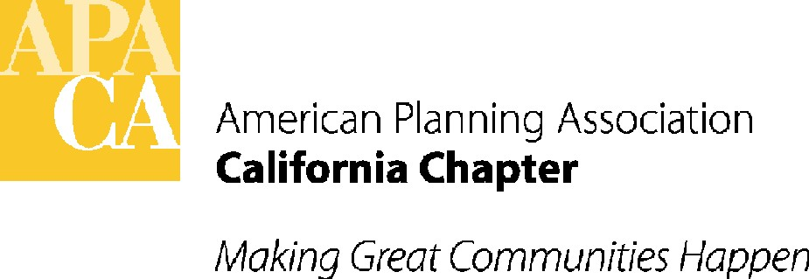

APA CALIFORNIA LEGISLATIVE UPDATE
March/APRIL 2013
By David Snow, AICP, Vice President Policy and Legislation
Sande George, APA California Lobbyist
Lauren De Valencia y Sanchez, APA California Lobbyist

The 2013 legislative session is off and running! The deadline for the legislature to introduce bills ended on February 22nd and with over 200 measures related to planning, the Legislative Review Team met on March 7th and 8th to review and take positions on bills of interest.

Committee hearings will begin in April and APA California plans to submit letters and lobby many important bills listed below. Hot topics this year will be related to: CEQA “updating”, urban agriculture, hydraulic fracturing, redevelopment alternatives, and potentially a 55% vote for local parcel taxes to be used for specific purposes.

Below is a list of hot bills that APA California will be working on along with the position the APA Legislative Review Team has taken. For an up-to-date list of all bills and summaries anytime, log on to the APA California website at www.calapa.org.com. If you or your agency have specific comments on any of these bills, please send them to lauren@stefangeorge.com. We will add them to our letters and lobbying efforts.

CEQA
AB 37 – Perea – Record of Proceedings – Support as Amended
AB 253 – Levine – Floating Home Marina Conversion – Watch
AB 380 – Dickinson – Notice requirements – Support if Amended
AB 417 – Patterson – Bicycle Transportation Plans – Support if Amended
AB 515 – Dickinson/SB 123 - Corbett – CEQA and Land Use Court –Watch
AB 543 – Campos – Translation – Support if Amended
AB 628 – Gorell – Energy Management Plans for Harbor and Port Districts – Watch
AB 794 – Gorell – Use of Landfill and Organic Waste – Oppose
AB 823 – Eggman – Ag Land Mitigation – Support if Amended
AB 930 – Hall - Energy Management Plans – Watch
AB 953 – Ammiano – Ballona Fix – Support if Amended
AB 1060 – Fox - CEQA Filing Fee Exemptions – Watch
AB 1079 – Bradford – Energy Management Plans – Watch
AB 1267 – Hall – Tribal Gaming Compact Notification – Watch
AB 1323 – Mitchell – Wind Energy – Watch
SB 436 – Jackson – Notice – Support if Amended
SB 525 – Galgiani – HSR Exemptions – Watch
SB 617 – Evans – Posting Notices with OPR – Support if Amended
SB 633 – Pavley – New Information – Watch
SB 731 – Steinberg – Rubio/Steinberg Framework –Watch
SB 787 – Berryhill –Standards Approach Alternative – Oppose Unless Amended

55% vote parcel tax measures
AB 59 – Parcel taxes/court decision on commercial vs residential rates – Watch
ACA 3/8 – Financing for public safety services – Watch
SCA 3 – Educational entities parcel tax – Watch
SCA 4/8 – Transportation projects – Support
SCA 7 – Public Libraries – Watch
SCA 9/11 – Vehicle for general authority for 55% vote for local special taxes for community and economic development projects – Support

Redevelopment/Redevelopment Alternatives
AB 28/1242/SB 133 – Enterprise zones – Watch
AB 229/243/1080 – Infrastructure and revitalization financing districts – Watch
AB 294/662/690/SB 33/628 – Infrastructure financing districts – Watch
AB 427/440 – Palanco Redevelopment Act – Watch
AB 562/750 – Economic Development subsidies – Watch
AB 564/981/1320/SB 341 – Successor agencies and housing successor – Watch
AB 930/1079 – Enterprise zones: energy management plans – Watch
SB 1 – Sustainable Communities Investment Authority – Watch
SB 636 –Excess ERAF moneys – Watch
SB 684 – Advertising agreements in former redevelopment project areas – Support if Amended
SB 692 –Communities facilities districts and Mello Roos – Watch
SB 752 – Commercial and industrial common interest developments – Watch

Hydraulic Fracturing
AB 7/982 – Watch
SB 4/665/802 – Watch

Urban Agriculture
AB 38 – The California Food, Farms and Jobs Act – Watch
AB 224 - Community–supported agriculture – Watch
AB 551 – Urban green space and ag property leasing – Watch

Other Bills of Interest
AB 52 – Project approval by Native Americans before project initiation – Watch
AB 116 – Two-year extension on map – Support if Amended
AB 325 – SOL for housing challenges – Oppose Unless Amended
AB 453 – Funding for SCS – Watch
AB 629 – Possible takings bill – Watch
AB 668 – Economic disaster area – Watch
AB 716 – State infrastructure plan/housing – Support if Amended
AB 728 – School siting and compliance with local zoning ordinances – Review expected amendments
AB 745 – COGs adjusting density for housing – Watch
AB 967 – Substandard housing determinations – Watch
AB 1002 – Vehicle fees for sustainable communities strategies – Review recent amendments
AB 1037 – Farmworker housing – Under review
AB 1092/SB 454 – Electric vehicle charge stations for projects – Oppose Unless Amended/Support
AB 1179 – School sites in SCS's – Review anticipated amendments
AB 1229 – Inclusionary zoning authority – Support
AB 1253 – Mobile advertising displays – Watch
AB 1359 – Quimby Act Fees – Watch
SB 391 – Permanent source of housing funding – Support
SB 553 – Fee votes/weighted votes – Watch
SB 673 – Cost benefit analyses for retail or commercial facilities – Watch

