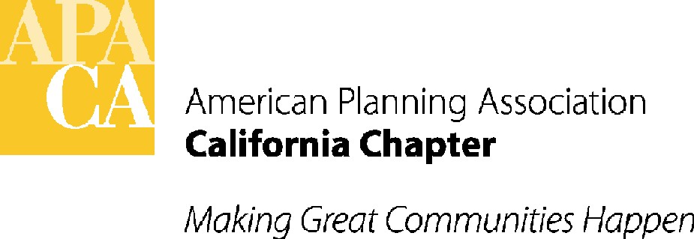

APA CALIFORNIA LEGISLATIVE UPDATE
January 2013
By David Snow, AICP, Vice President Policy and Legislation
Sande George, APA California Lobbyist
Lauren De Valencia y Sanchez, APA California Lobbyist

Implementation of AB 1616 Cottage Food Facilities in Residential Areas

Many local governments are in the process of approving ordinances to implement the planning and zoning provisions of AB 1616, which goes into effect January 1, 2013. AB 1616 was amended on the last few days of session to include a cottage food operation that is registered or has a permit within the private home exemption of the California Retail Food Code, and to exclude a cottage food operation from specified food processing establishment and Sherman Law requirements. It also will require a cottage food operation to meet specified requirements relating to training, sanitation, preparation, labeling, and permissible types of sales and would subject a cottage food operation to limited inspections. Important to APA, it also will establish various zoning and permit requirements relating to cottage food operations. The Governor signed the bill into law in September.
APA California supported the goal of the bill. However, APA along with the California State Association of Counties (CSAC), the League of California Cities, the Regional Council of Rural Counties (RCRC), and the Urban Counties Caucus notified the author of the bill that the bill was not clear in a number of areas and such confusing provisions would make it difficult for cities and counties to implement the bill.

Since that time, APA has been participating in an implementation working group with the author’s staff, health inspectors and other local government associations. We have discussed our main concerns with the author’s staff to better understand the intent of specific provisions, and believe that clarification of these sections is necessary to ensure the requirements are clear for those that will be required to enforce them, and to reconcile differences between various sections of the bill.

The author has agreed to ask the Legislature’s Legislative Counsel to quickly answer these questions before January 1, and to help us determine which clarifications may need further legislative action.

Below is a list of the questions that need clarification. Of chief concern is the extent to which cities and counties will be able to regulate specific impacts of what will be quasi-commercial operations in residential areas under the express language in AB 1616.

- POINT OF SALE AT RESIDENCE: Can cities and counties specifically prohibit the point of sale of cottage food products out of the residence or residence kitchen? Currently the bill defines direct sale as selling to consumers not located at the residence, but would also define direct sale to include selling of products directly to consumers from the cottage food operation. (Page 6, Sec. 113758 (4) defines "direct sale" to be transactions "occurring in person in the cottage food operation.") Do Sec. 113758 (4) and Sec. 51035 (a) (2) and (3) allow cities and counties to continue to prohibit point of sale of cottage food from a residence or residence kitchen to address the potential traffic and commercial impacts in residential areas? As a general matter, local agencies would like to be specifically authorized to continue to apply the generally applicable home occupations standards to cottage food operations as necessary to protect residential areas, with the exception of allowing the one outside employee, which is unlikely to transform a residential area. However, as written it is unclear.

- VERIFICATION OF FEES ON COTTAGE FOOD OPERATONS: Can the city or county use an existing fee study, completed to establish the cottage food operation permit fee pursuant to existing fee authority, to meet the bill’s requirement for verification of fees and breakdown of individual fees charged by the city or county? The bill specifically requires the local government to process any required permit not to exceed the costs of the review and permit process, as already required by existing fee statutes. But the bill would additionally authorize an applicant to demand an accounting breakdown of verification of fees and "any individual fees charged in connection with the issuance of the permit". [Pages 3 and 4, Sec. 51035 (a) (3) and (b) (2)] An existing fee study that analyzed the costs of issuing the permit to be required for the cottage food operation by the city or county should be sufficient to meet these requirements.

- RESIDENTIAL USE VS COMMERICAL FOOD OPERATION: Can cities and counties through the permit process and implementing ordinance for a cottage food operation continue to address specific safety issues and impacts on neighboring residences resulting from the commercial food operations? Are local agencies limited to the specific permit restrictions listed in the bill? AB 1616 in Sec. 51035 (a) (2) and (3) allows cities to issue permits that comply with local ordinances prescribing reasonable standards, restrictions, and requirements for a cottage food operation. That section then goes on to list specific issues that can be addressed. The bill also mandates that the use of a residence for the purposes of a cottage food operation would not constitute a change of occupancy for purposes of the State Housing Law, or for purposes of local building and fire codes, and that cottage food operations must be considered residences for the purposes of the State Uniform Building Standards Code and local building and fire codes. [(Sec. 51035, (c) and (d)] Cities and counties would like to remain authorized to address specific safety issues and impacts on neighboring residences resulting from these cottage food commercial uses, such as prohibiting signage, requiring grease traps so neighborhood sewers are protected, mandating fire clearances around commercial ovens, adequate ventilation to control odors, proper fire suppression, garbage collection and pickup, and limits on hours of operation. Many of these issues are even more important when the operations are located in a multifamily residential building.

- PERMIT AND FEE INFORMATION FROM UNRELATED PUBLIC AGENCIES: Are cities and counties mandated to provide cottage food facility applicants a list of the permits, fees and fee verification required by public agencies that are not under the cities’ or counties’ control? The bill appears to require the city or county, upon the request of the applicant, to provide a list of the permits and fees and unspecified other information required not only by the city or county or other city or county departments, but by other public agencies which are not under the control of the city or county. [Page 4, Sec. 51035 (b) (1)] This is not information that the city and county will be able to provide.

If you have any other issues of concern, please email Sande George at sgeorge@stefangeorge.com. APA will provide members with an update as soon as we have written decisions from Legislative Counsel.

Legislature Returns January 7

The California Legislature met for one day December 3 to swear in new members and begin the process of introducing new bills. As everyone knows, both the Senate and Assembly Democrats now hold a 2/3-majority vote. What they decide to do with that 2/3 vote is still open, but indications are that Democrats plan to be judicious with their agenda. On that agenda so far: CEQA updating and exploration of possible updates to Prop 13 such as a higher property tax rate for commercial property and potentially a 55% vote for local parcel taxes to be used for specific purposes. The Legislature returns full time on January 7. Below are a few of the more interesting bills that have been introduced so far. Look on the APA website for additional legislative information.

AB 1 (Alejo) Water quality: integrated plan: Salinas Valley.
This bill would appropriate $2,000,000 to the state Water Board for use by the Greater Monterey County Regional Water Management Group (management group) to develop an integrated plan to address the drinking water and wastewater needs of disadvantaged communities in the Salinas Valley whose waters have been affected by waste discharges.

AB 5 (Ammiano) Homelessness.
This bill would enact the Homeless Person's Bill of Rights and Fairness Act, which would provide that no person's rights, privileges, or access to public services may be denied or abridged because he or she is homeless, has a low income, or suffers from a mental illness or physical disability.

AB 21 (Alejo) Safe Drinking Water Small Community Grant Fund.
This bill would authorize the department to assess an annual charge in connection with loans for water projects in disadvantaged communities made pursuant to a new Safe Drinking Water Small Community Grant Fund.

AB 22 (Blumenfield) Sidewalk Repairs.
This bill, back again from last year, would prohibit a city or county that has an ordinance in operation that requires the city or county to repair or reconstruct streets, sidewalks, or driveways that have been damaged as a result of tree growth from repealing the ordinance without the concurrence of the local electorate by majority vote.

AB 37 (Perea) Environmental quality: California Environmental Quality Act: record of proceedings.
Similar to two measures stalled last year, this bill would require the lead agency, at the request of a project applicant, to prepare a record of proceedings concurrently with the preparation of negative declarations, mitigated negative declarations, EIRs, or other environmental documents for specified projects.

SB 1 (Steinberg) Sustainable Communities Investment Authority.
Another reintroduction of a 2012 bill, this bill would authorize public entities of a Sustainable Communities Investment Area to form a Sustainable Communities Investment Authority. The bill would require the authority to adopt a Sustainable Communities Investment Plan and authorize the authority to include in that plan a provision for the receipt of tax increment funds provided that certain economic development and planning requirements are met.
SB 33 (Wolk) Infrastructure financing districts: voter approval: repeal.
This bill would revise and recast the provisions governing infrastructure-financing districts. The bill would eliminate the requirement of voter approval for creation of the district and for bond issuance, and would authorize the legislative body to create the district. The bill would instead authorize a newly created public financing authority, consisting of 5 members, 3 of whom are members of the city council or board of supervisors that established the district, and 2 of whom are members of the public, to adopt the infrastructure financing plan, subject to approval by the legislative body, and issue bonds by majority vote of the authority by resolution. The bill would authorize a district to finance specified actions and projects, and prohibit the district from providing financial assistance to a vehicle dealer or big box retailer.

SCA 3 (Leno) Taxation: educational entities: parcel tax.
This measure would authorize a school district, community college district, or county office of education to impose a parcel tax if 55% of the voters approve the tax rather than 2/3.

SCA 4 (Liu) Local government transportation projects: special taxes: voter approval.
This measure would provide that the imposition, extension, or increase of a special tax by a local government for the purpose of providing funding for local transportation projects requires the approval of 55% of its voters voting on the proposition rather than 2/3 vote.

