AGENDA ITEM

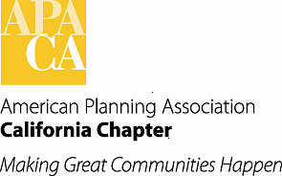

TO: APA California Chapter Board

FROM: Kristen Asp, AICP, Vice President of Administration

DATE: January 16, 2015

SUBJECT: 2015 Budget

Recommended Action:

Review the adopted 2015 Budget, discuss, and amend if necessary.

Background:

The Board adopted the 2015 Budget at our Board meeting in September.

On our Executive Board call on December 5, 2014, the Board moved, seconded and passed a motion to grant Tom Stefan the authority to withdrawal funds from reserves to make up for the shortfall from the 2014 conference profits. The Board agreed to give Tom Stefan the ability to determine the best time and the amount(s) needed for the withdrawal, estimated to be between $50,000 to $70,000.

Update:

It was estimated that $60,000 would be needed to carry the Chapter through mid-February (when we get our next subvention check from National). At the end of last year $46,000 was transferred to the general account from Reserves. The Chapter had $347,000 in Reserves and after this withdrawal leaves a balance of $301,000. There is currently $5,700 in our account now and combined with the conference share and the Reserve withdrawal should carry us.

Attachment:

Adopted 2015 Budget

