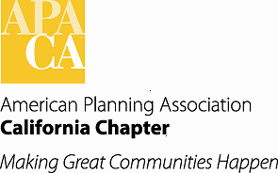

**TO: APA California Chapter Board Meeting**

**FROM: Betsy McCullough, AICP, Vice President of Conferences**

**DATE: January 16, 2016**

**SUBJECT: 2017 Chapter Conference (Sacramento Valley Section) Status**

*This is an information report. No action is required from the Chapter Board.*

The Sacramento Valley Section Co-Chairs were approved by the Board in June 2015. They have begun their preliminary organizing work, including phone calls with the Vice President of Conferences and the Conference Management Consultant. Following is a status report from co-chairs Bob Lagomarsino, David Kwong, and Jeannie Lee:

On November 25, 2015, the Conference Committee Co-chairs and the Section Leadership met to discuss the following items:

1. Themes for the conference including approaches to soliciting ideas from the Sacramento Valley Section Board during the Annual Retreat in January 2016 and from membership via Section newsletter. The committee wanted to be as inclusive as possible and acquire broad based input, while at the same time defining parameters for obtaining ideas and landing on a theme,
2. Keynote addresses and speakers,
3. Site visits to the conference facilities and determining and securing opening reception venue,
4. Announce Conference Committee Co-chairs in January 2016 to Section membership and call for conference volunteers (committee chairs and other committee volunteers),
5. Establishing monthly meetings with Conference Committee Co-chairs beginning in February 2016, and
6. Use of the conference budget and the conference contractor to assist with logistics and to help organize around these items.

Respectfully,

2017 Co-Chairs and Section Leadership

The Co-Chairs, Vice President of Conferences and Conference Management Consultant will have a call to discuss various budget-related items on December 22, 2015.