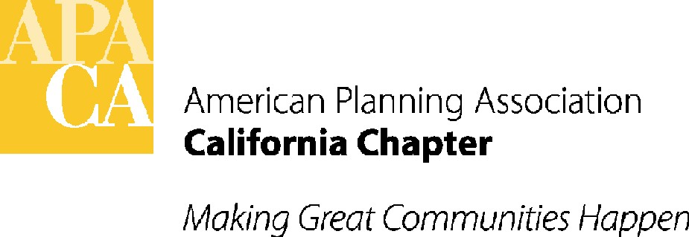

ACTION MINUTES

APA California Board Meeting

Friday, June 7, 2013
APA Conference Line
ATTENDEES:
EXECUTIVE BOARD
President Brooke Peterson, AICP
VP, Policy & Legislation David Snow, AICP
VP, Public Information Hing Wong, FAICP
VP, Professional Development Betsy McCullough, AICP
VP, Administration Virginia Viado
VP, Conferences Kurt Christiansen, AICP
VP, Membership & Marketing William Hoose, AICP
Past President Kevin Keller, AICP
CPF President Carol Barrett, FAICP
Commission and Board Representative Marc Yeber

SECTION DIRECTORS
Central Ralph Kachadourian
Northern Jeff Baker
Orange County Jennifer Lilley, AICP
Sacramento Valley Trisha Stevens, AICP
San Diego Greg Konar, AICP
Central Coast Dave Ward
Inland Empire Aaron Pfannenstiel, AICP
Los Angeles Marissa Aho, AICP

STAFF
Executive Director/Lobbyist Sande George
Director of Administration Tom Stefan
Lobbyist Lauren De Valencia y Sanchez

ACTION ITEMS FROM BOARD MEETING

- CALL TO ORDER
President Brooke Peterson called the meeting to order at 9:30 am.
- APPROVAL OF CONSENT ITEMS
Approval of Agenda, Membership Report and 2013 Financial Report: The Board moved, seconded and passed to approve the Consent Items. Unanimous vote.
Approval of January 2013 Minutes: The Board moved, seconded and passed to approve the January 11th/12th Board Meeting and Retreat Minutes with an edit to change Carol Barrett’s title to CPF President. Unanimous vote.
- ACTION ITEMS
Approval of the Bylaws: Brooke Peterson presented the Bylaws, which include some minor changes from the draft given to the Board at the January Board meeting. Virginia Viado noted there should be a clarification under PEN. Currently, it reads that the Chapter President appoints the PEN president. However, in practice the PEN Board appoints its own president. It was also requested that under the Chapter Committees section, it would be helpful to have a list of the standing committees to help new Board members. Brooke will amend the PEN appointment language, add the standing committees, and work with Marc Yeber between now and the fall meeting to make changes to the Board and Commission Representative section that they have discussed offline. The Board moved, seconded and passed to approve the Bylaws. Unanimous vote
Strategic Plan: Brooke asked the Section Directors to provide a discussion of their collective goals for the Strategic Plan. Because Brooke would like to bring back the final draft of the Strategic Plan for Board approval at the fall Board Meeting, Section Directors decided to arrange a call in July to discuss draft goals for the Strategic Plan and to meet in-person at the fall Board meeting to finalize. Brooke will participate in the call and meeting; other Board members interested may also participate. Brooke will also work with the VPs before the next Board meeting to make sure the goals in the Strategic Plan for each portfolio are accurate, as she drafted them based on the feedback she received from the retreat.

Website Update: The new website has been a year long process and it’s now close to being launched. There are two sections of the website that are in their final stages of completion. The website will be launched after they are completed to the full APA California membership via eblast, likely in mid-July. Those who visit the old URL will be redirected to the new site and all members will be prompted to change their log in password.
Budget Update: The Budget Committee will be appointed by Brooke Peterson, consisting of the President, Vice Presidents, other elected positions, and two Section Directors. The first meeting will be in August. The Committee will submit a draft proposed budget to the Board for its comments in advance of the fall Board meeting and the final budget for vote will be submitted to the Board for adoption at that fall Board meeting.
Conference Manager Contract Evaluation: The Contract Committee received a variety of comments from Board members and contractors on the Conference Manager Contract. Per the Contract Evaluation Protocol approved in 2012, the Evaluation Report will be reviewed by the Executive Committee and a synopsis of the feedback will be brought back to the Board at the fall Board meeting.
FAICP Process Update: The FAICP eligible list was received last week. The changes in National’s Application Guidelines are being reviewed to see if changes need to be made to the Chapter’s preliminary application. There will likely be a conference call in July to work on suggestions for categories that would be appropriate for Sections and the results will be brought back to the fall Board Meeting. The Board will also need to approve a list of FAICP nominees. The list will be sent for a vote via email.
Elections Update: Kevin Keller has been pulling together all the materials for the upcoming elections. The Elections Nominating Committee will meet in July. The election nominations will be sent out in September to be approved by the Board. The current open positions are: President, VP of Public Information and VP of Administration. Kevin will coordinate with Brooke on the VP of Marketing and Membership position as it’s not clear when the election cycle for that position will be. Kevin will also be asking current Board members that have only served one term if they want to stay involved in their position.

Marketing and Membership Update: William Hoose reported that his marketing and membership committee would like to create a welcome package for new members that could be housed on the website in the Board Binder that both the Chapter and Sections can use. This could be created from existing materials already available from National as well as the current new member welcome letter that the Chapter sends. The committee also suggested a new Chapter-wide survey to guide future marketing and membership activities and Chapter budgeting. Carol Barrett suggested that the committee first review the data from a previous survey just completed in 2010 that could be informative. If the committee believes updated data, or more targeted information is still needed, a short survey could be considered at a later date.

Next Executive Board Conference Call Moved: The next Executive Board conference call will be moved to Friday, July 12th due to the 4th of July holiday.

- ADJOURNMENT
The Board Meeting was adjourned at 12:30 pm.

