AGENDA ITEM_0-3__

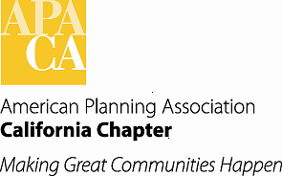

TO: APA Chapter Board

FROM: Kurt Christiansen, AICP
Vice President of Conferences

DATE: October 5/6, 2012

SUBJECT: 2015 Conference Update

The Northern Section will be hosting the 2015 Chapter Conference in Oakland, California, at the Oakland Marriott, October 3 -6, 2015. An organizational meeting was held on September 14, 2013. At the kick off meeting the various conference committee positions were explained. The Northern Section has developed a committee sign up form to provide interested volunteers the opportunity to understand each position, the level of commitment and express their desire to participate. The Section is excited about the enthusiasm and will be working to recruit the full CHC by November, 2013.
Anticipated room rate would be $159/night. The location and facility amenities afford our membership with transportation options to and from the conference, close proximity to a BART station, with service from both OAK and SFO.
The 2015 conference will be following the new format approved by the Board in January of 2012 and the Northern CHC will be working with VP Conferences to implement this new schedule as it relates to redesigning Sunday to be all day of conference sessions, the Board activities, student day and other shifts that may need to occur due to shifting away from the half day conference on Wednesday. This conference schedule change also includes coordinating with the State and host committee to provide options for a Saturday professional development day.
The section has nominated Erik Balsley and Hing Wong to serve as co-chairs for the conference.

