AGENDA ITEM__O-4a____

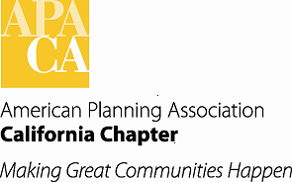

TO: APA Chapter Board

FROM: Kurt Christiansen, AICP
Vice President of Conferences

DATE: October 5/6, 2012

SUBJECT: 2016 Conference Update

The Los Angeles Section will be hosting the 2016 APA CA Chapter Conference. On September 13, 2013, a site inspection was conducted in Pasadena, California. In attendance were the following:
Kurt Christiansen, AICP Vice President for Conferences
Lynne Bynder Conference Coordinator
Marissa Aho, AICP Los Angeles Section Director
Vince Bertoni, AICP Pasadena Planning Director

The Los Angeles Section is requesting approval of the 2016 conference location and dates. The attached proposal outlines the basic information regard the facilities located in Pasadena. The Section proposes to use the Pasadena Convention Center for the meeting space. There are three options for the hotel rooms, but the section has asked for additional time to select the right hotel venues. Information regarding all of the hotels is in the attachment. The Section also looked at venues in West Los Angeles, but none of the facilities could handle the minimum numbers set in the conference manual. A spread sheet comparing all of the locations is attached.

Another decision needed to be made by the Board is the conference dates. The Pasadena Convention Bureau has proposed 2 sets of dates: September 24-27, 2016 and October 22-25, 2016.

The Los Angeles Section is recommending the October 22-25, 2016 dates. This is to ensure that all of our Planning School Programs will be in session. It also misses all of the religious holidays.

BOARD ACTION:

Approve the selection of Pasadena as the site of the 2016 APA CA Conference for October 22-25, 2016 and direct the section to bring back a recommendation for the hotel/s

