Date: September 24, 2013

To: Kurt Christiansen, AICP, Vice President for Conferences

From: APA Los Angeles Board/Marissa Aho, AICP, Section Director:

Subject: Recommendation for 2016 APA California Chapter Conference
______________________________________________________________________________

RECOMMENDATION

The APA California Los Angeles Section recommends that the Chapter Board consider one site for the 2016 APA California Chapter Conference:

- Pasadena Convention Center on Oct. 22-25, 2016 (with a possible back-up date of Sept. 24-27.)
- With hotel space in the Westin Pasadena and/or the Hilton Pasadena and/or the Sheraton Pasadena.

The Board believes that Pasadena will be excellent choice for the conference. This site was previously host to the California Chapter Conference in 1994. Since then the City has undergone a transformation and the Convention Center facilities have been remodeled and upgraded.

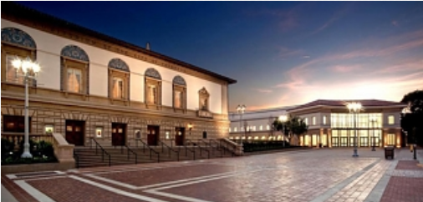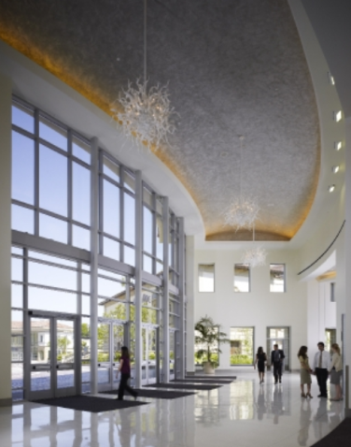

We also strongly considered having Santa Monica or another “beach” city host the conference, but the facilities were not sufficient in size or amenities. Attachment A provides a comparison of all of the sites that were looked at.

A brief history of APA Conferences in Los Angeles:
2012 – Downtown Los Angeles (National)
2008 – Hollywood
2000 – Long Beach
1994 – Pasadena

Additionally, the Board recognizes that the City of Pasadena is home to many talented APA members and Planning firms and has the full support of the City of Pasadena’s Planning & Community Development Director Vince Bertoni, AICP.

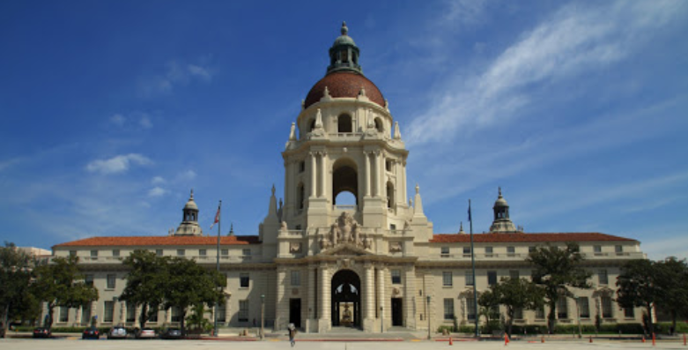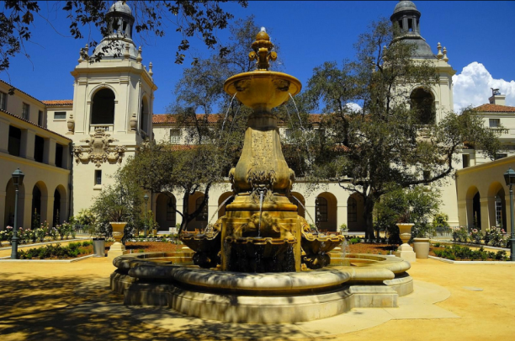

HOTELS

We are in the middle of negotiations with the Westin, Hilton, and Sheraton, which have all offered competitive rates of between $149 and $179 for either a total block or ½ block. We look forward to providing additional details for the Chapter Board to consider on or before the January retreat/board meeting.

