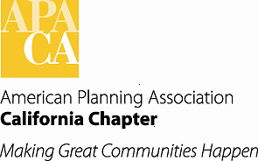 Agenda Item # G-1

**TO: APA California Chapter Board**

**FROM: Betsy McCullough, AICP, Vice President of Professional Development**

**DATE: Board Retreat, January 2014**

**SUBJECT: Overall Status**

This is an information report. It is a status of Professional Development activities.

Refer to the Professional Development Section of the 2013 Annual Report for an in-depth discussion of the activities of the Vice President of Professional Development and the team for 2013.

At the time of this report, among many ongoing efforts:

* We are waiting for notification from APA National about the number of Chapter members who took and passed the AICP Exam in November 2013
* The Chapter team is in the process of considering applications and awarding AICP Scholarships for the May 2014 AICP Exam
* We are waiting to receive notification about the success of our 10 FAICP nominees being accepted in to the College of Fellows of AICP
* We are preparing to update the FAICP Nomination Guidelines
* We are preparing, with the leadership of Brooke Peterson, to address the Chapter Presidents Council about evolving paper CM Evaluation forms to electronic format
* Section PDOs are preparing to conduct AICP Exam Prep training sessions

In addition, two additional topics of are included in the Professional Development report to the Board Retreat as separate reports:

* Endorsement of a CM Event Co-Sponsorship Procedure for use by the Chapter and Sections
* Endorsement of a work effort to develop a webinar capacity for the Chapter and Sections