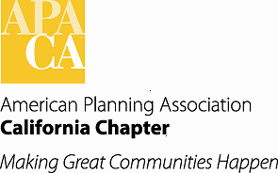 Agenda Item # G-2a

**TO: APA California Chapter Board**

**FROM: Betsy McCullough, AICP, Vice President for Professional Development**

**DATE: Board Retreat, January 2014**

**SUBJECT: CM Event Co-Sponsorships**

Recommended Action:

*Review the attached CM Event Co-Sponsorship Request Form, provide any comments, and refer to the Section PDOs for any additional comments. Implement!*

Background:

Former Vice President for Professional Development, Juan Borrelli, prepared a draft co-sponsorship form for use by the Chapter and Section PDOs. The Board approved it but I found it only in draft form upon my becoming VP.

It has been streamlined and now builds on the CM Event Activities form that we will ask co-sponsorship requestors to fill out [the form that is filled out for CM Event approval and submitted to APA National].

I am requesting the Board review the newly-drafted form and approve it for review by the Section PDOs and for use.

Fiscal Impact:

Creating this form causes no fiscal impact since the Chapter and Sections are already co-sponsoring events with other organizations. It does remind Section PDOs that it is appropriate to request that our Chapter members receive a registration discount in exchange for the Chapter or Section being the CM credit co-sponsor.

Attachments:

One attachment with the Chapter-developed CM Event Co-Sponsorship Request Form and the APA National CM Activities Form.