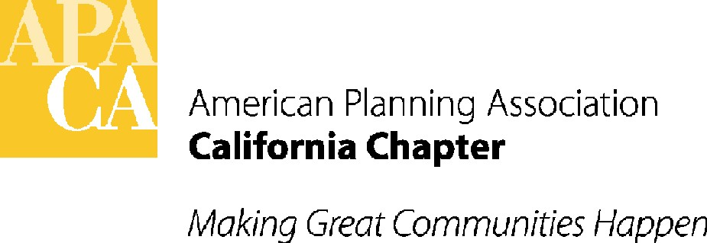

TO: APA CALIFORNIA BOARD OF DIRECTORS

FROM: KRISTEN ASP, VP FOR ADMINISTRATION

DATE: JUNE 16, 2017

SUBJECT: APPROVE RECOMMENDATIONS FROM APA CALIFORNIA ACCOUNTANT AND OVERAGES

RECOMMENDED ACTION: Approve the recommendations from the Chapter accountant for changes in the Chapter accounting, approve funding to pay the accountant to implement the accounting changes, and approve funding to train the Chapter bookkeeper to maintain the revised Chapter books. Approve UBIT overage to reflect actual taxes owed for 2017. Approve appointment of Accounting and Financial Stability Subcommittee.

BACKGROUND: APA California this year hired a new accountant after our long-time accountant decided not to continue tax services for the Chapter/Sections. As part of the contract with the new accountant, the Chapter asked the accountant to make recommendations to:
- Update APA’s books so they are in order and are in line with the much larger and more complex organization that we are now (compared to when our original books were set up).
- Make the accounting process easier to track.
- Reduce the amount of time that the Chapter’s bookkeeper and the accountant will need to maintain the books and complete tax returns.

ACCOUNTANT RECOMMENDATIONS:
- Create one set of books for all accounting activity of APA beginning 7/1/2017.
- Change treatment of inter-fund transfers and ensure timing and treatment of transactions are consistently recorded and in proper line items.
- Revise chart of accounts to reflect changes recommended.
- Clarify Section expenses and maintain consistency with Chapter Chart of Accounts.

ACTION REQUESTED OF THE BOARD:
- Approve the accountant’s recommendations (full recommendations from the accountant are included starting on page 3 of this report).
- Approve the accountant’s fee of $6,000 to implement the accounting changes recommended.
- Approve training of the Chapter’s bookkeeper by the new accountant in the amount of $135 per hour to allow her to maintain the new books up to a total of $3,000, unless a higher amount is approved by the Board.
- Approve an overage of $9,000 in LI 603 to cover items 2 and 3 – Accountant/Tax Services, to be paid out of the $21,000 cash flow “cushion” recommended by the Conference Profits Committee.
- Approve overage in LI 609 – UBIT Taxes to pay 2017 UBIT tax pre-payments to IRS and State, in the amount of $121 to be paid out of cash flow.
- Approve Accounting and Financial Stability Subcommittee. This subcommittee will review the complete financial picture for the Chapter and Sections, including changes that should be considered given the Chapter’s current size and complicated Chapter/Section/Conference accounting, how much money flows in various directions (e.g. to the conference accounts, to the Sections and to various expenses), and what our financial picture should look like over the next 1-3 years. It will also review the accountant’s recommendations related to bookkeeping and accounting for the Chapter and Sections, tax implications, liability and oversight, and make recommendations to ensure the Chapter is on solid financial footing going forward.



Bowman & Company, LLP
10100 Trinity Parkway, Suite 310
Stockton, California 95219
p. 209.473.1040
f. 209.473.9771 www.cpabowman.com

American Planning Association – California Chapter
June, 2017

Here is a list of some of the accounting issues we encountered when we were preparing APA’s 2016 Tax Exempt Return:

- We were given 4 QuickBooks (QB) files, basically 4 different sets of books for APA. There was one set of books for APA’s 2 general bank accounts and 3 sets of books for the accounting of the conference activities (a set for each of the 3 conference bank accounts). There was no consistency in the recording of the inter-fund transfers between the bank accounts. An inter-fund transfer may be recorded as an income or expense on one set of books and as a receivable or payable on another set. These type of transfers should be recorded as Balance Sheet activities. When the inter-fund transfers are recorded as income statement activities, they may not have an effect on the net income but they overstated the Association’s gross income and expenses. There were also timing issues on these transfers at year end. For example, a transaction would be recorded on one of set books at year end and on another set, it would not be recorded until the following year. Recommendation: Create one set of books for all accounting activity of APA. Classes can be used to identify and track conference accounting. All inter-fund transfers should be accounted for through the balance sheet using Due to/Due from accounts and should tie out at all times.

- The excel worksheet on the reporting of the Sections’ income and expenses did not separate the transfers between the Sections and the Chapter. The transfers were included as either income or expenses for each of the Sections. Basically, when the Chapter transferred part of the dues income and conference profits to Sections, they were recorded as expenses on Chapter books and the Sections pick these transfers up as income. When the books are consolidated, the income and expenses should off-set each other but there were timing issues. There were activities recorded at year end on the Chapter’s books but not reflected on the Sections’ records until the following year. Due to the timing on these transfers, the consolidated financial statements of APA at year end does not truly present its' financial position. Recommendation: transfers should not be included in the income statement at all. Transfers should be set up as Due to/Due from and reconciled monthly. Timing differences should not exist.

- The account numbers on the chart of accounts were not assigned in chronological order. When we were recording the adjusting journal entries, it was very time consuming to look through the chart to find the accounts. Generally, the 100's are assigned to assets, 200's to liabilities, 300's to equities and so on; on APA’s chart of accounts, there were no account numbers assigned to the bank accounts, 200's and 400’s were used for both liabilities and expenses, 100's were mixed with equities and expenses and 01-93 were used for income. To be more efficient in recording APA's activities, the chart of accounts needs to be revamped. Recommendation: Start over with a new chart of accounts when all the accounting is consolidated into one set of books.

- The QB bank reconciliation reports provided to us was not reconciled to the QB general ledgers (GL) ending bank balances. The discrepancies were due to either different transaction amounts between the GL and the bank reconciliation reports or the transactions were not on the bank reconciliation report at all. We assumed those transactions that were not on the bank reconciliation report must have been recorded after bank reconciliation reports were done. Recommendation: Bank reconciliations should be prepared monthly for every bank account and reconciled to the bank statement as well as the general ledger. Without reconciled bank accounts that agree to the GL, there is no way to determine if all the activity has been recorded. Best practices would advise that there should be a separate person doing the bank reconciliation from the person in charge of the general ledger and paying the bills and making deposits.

- When APA's return was prepared, we made the assumption on the item listed as "Scholarship/Mentoring" on the Section excel worksheet as mentoring expense. If this item was for scholarships, then we will need additional information from the Sections such as the name, address and amount on each of the recipients. Recommendation: Research this expense to determine the proper treatment on the returns.

- The miscellaneous income and miscellaneous expense amounts should generally be under $5,000 on a 990. There was $45,360 in miscellaneous income and $29,869 in miscellaneous expenses on the 2016 990. Recommendation: Determine what the nature is of the miscellaneous income and expense and categorize it accordingly.

- Overall recommendation: We believe the accounting system needs to be redone. A new chart of accounts should be created and one set of books should be used to record all activity of APA. We would recommend starting with the ending reconciled balances of June, and setting up a new set of books beginning 7/1/17.

