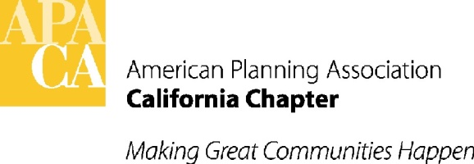
January 16, 2015
TO: APA California Chapter Board
FR: Kristen Asp, VP Administration
RE: Annual Report 2015

Background:
APA California Chapter released its first ‘Annual Report’ in early 2013 and has since been preparing one annually. The report presents information on the various activities and events supported by the Chapter by highlighting key Chapter events. The report also spotlights VP portfolio activities and programs held throughout the year, events and activities from each of the eight Local Sections as well as our affiliate organizations including CPF, CPR and PEN. Once prepared, the report is distributed to our partner/affiliate organizations and available to our members through our website.
Action:

To date, we have received a handful of summaries. Please prepare your summaries and submit to me no later than Friday, January 29, 2016. As a resource, I’ve included the guidelines again for reference and direct you to the last year’s report on our website. Should you have any questions, please let me know. Individual and group photos will be taken during the retreat for use in the report.

https://www.apacalifornia.org/about/annual-report/ DON’T FORGET TO LOGIN!

Attachment:

Annual Report Guidelines

APA CA Annual Report Guidelines

In efforts to assist you with preparing information for your individual sections, the following guidelines are provided for submitting material for APA California’s annual report.
EXECUTIVE BOARD:
Length
- 1-3 pages maximum (including pictures), or as needed
Content
- Highlight programs and accomplishments of the year
- Recognize incoming and outgoing program chairs/coordinators (or identify vacancies if available)
- Discuss applicable upcoming programs

SECTIONS/AFFILIATED ORGANIZATION MEMBERS:
Length
- 1-2 pages maximum (including pictures)
Content
- Highlight activities and programs of the section/organization
  - Local awards
  - On-going member programs
  - Successful events
  - Upcoming programs
  - Encourage member participation through volunteering on committees or running for open Board positions

DOC FORMAT: working(or open) MS WORD file (.doc or .docx). No .PDF, PowerPoint and InDesign please.
PHOTOS:
- Ok to imbed photos in WORD file for “placement only”
- Send all photos as separate files, named accordingly
- Photos should be submitted in jpeg or pdf at 300 resolution

GRAPHS AND CHARTS: (similar to photos above)
- Ok to imbed photos in WORD file for “placement only”
- Send all photos as separate files, named accordingly
- Charts/graphs should be submitted in jpeg or pdf at 300 resolution
- If edits are needed after initial submittal, a new file shall be submitted

QUESTIONS: should you have additional questions about photos, graphs or charts, please contact:
- Dorina Blythe – dorina@grandesigns.us, or
- Kristen Asp – kasp@glendaleca.gov

