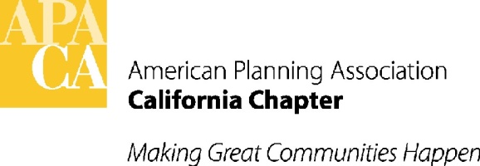
October, 3 2015
TO: APA California Chapter Board
FR: Kristen Asp, VP Administration
RE: Annual Report Guidelines

In efforts to assist you with preparing information for your individual sections, the following guidelines are provided for submitting material for APA California’s annual report.
EXECUTIVE BOARD:
Length
- 1-3 pages maximum (including pictures), or as needed
Content
- Highlight programs and accomplishments of the year
- Recognize incoming and outgoing program chairs/coordinators (or identify vacancies if available)
- Discuss applicable upcoming programs

SECTIONS/AFFILIATED ORGANIZATION MEMBERS:
Length
- 1-2 pages maximum (including pictures)
Content
- Highlight activities and programs of the section/organization
  - Local awards
  - On-going member programs
  - Successful events
  - Upcoming programs
  - Encourage member participation through volunteering on committees or running for open Board positions

DOC FORMAT: working(or open) MS WORD file (.doc or .docx). No .PDF, PowerPoint and InDesign please.
PHOTOS:
- Ok to imbed photos in WORD file for “placement only”
- Send all photos as separate files, named accordingly
- Photos should be submitted in jpeg or pdf at 300 resolution

GRAPHS AND CHARTS: (similar to photos above)
- Ok to imbed photos in WORD file for “placement only”
- Send all photos as separate files, named accordingly
- Charts/graphs should be submitted in jpeg or pdf at 300 resolution
- If edits are needed after initial submittal, a new file shall be submitted

QUESTIONS: should you have additional questions about photos, graphs or charts, please contact:
- Dorina Blythe – dorina@grandesigns.us, or
- Kristen Asp – kasp@glendaleca.gov

DEADLINE:
The deadline to submit information for the 2015 Annual Report is December 11, 2015.

