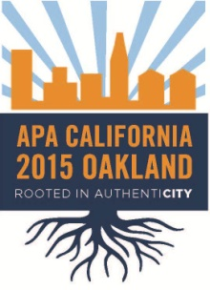
2015 California Planning Conference Local Host Committee
June 2014 Board Report

June meeting
The LHC held a meeting on Saturday June 7 from 10AM – Noon at the MetroCenter, 101 Eighth St, Oakland. We presented our new conference logo (see above) to go with our theme “Rooted in AuthenCity.” We’ve had a two chair changes since April:

- Fundraising - Jean Long
- Volunteers - Syd Wayman

The committees are now meeting outside the LHC meetings to continue their work. They will report back on their progress and activities at the next meeting in August.

Chapter Coordination
The Co-Chairs had a conference call on May 9th with Kurt Christensen, VP of Conferences, to discuss preliminary budgets and other chapter items. We developed a preliminary budget that we will continue to refine by the end of July.

Anaheim Conference
We will be ordering give-aways for the Anaheim Conference (9/13-16). We have set up volunteer shifts to staff the 2015 Oakland conference table.

Next LHC Meetings (10 am to noon):
8/9 – URS, 1333 Broadway, Ste 800, Oakland
10/11 – TBD
12/13 – TBD

