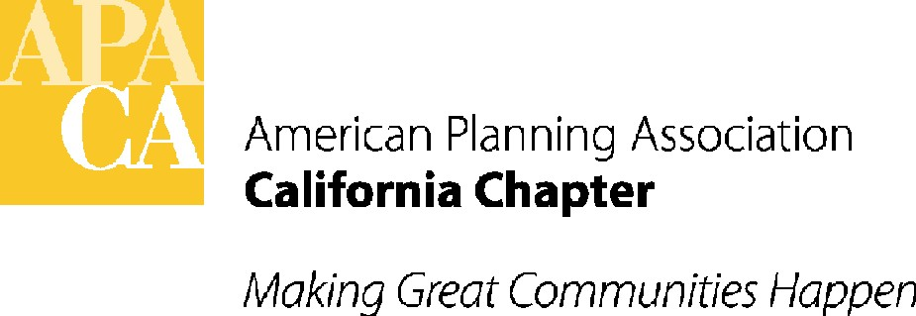 Attachment H
Date: June 20th, 2014
From: Lauren De Valencia
To: APA California Board of Directors
Subject: Public Relation Program Outline

Objective: This document is a recommendation based on the Strategic Plan – Implementation Work Program Matrix item number five, which was developed at the January 2014 Board Retreat. Goal number five states:

“To enhance our profile and visibility such that APA is THE authority on planning to members, nonmembers we want to recruit, and other related professionals/opinion leaders we want to familiarize with APA.”

This document should serve as a guideline for the Board to develop a Public Relations Program (PR Program) for targeted outreach to: 1.) the media/public; 2.) current members/potential new members and; 3.) the Legislature.
RECOMMENDATIONS FOR INITIATING A PR PROGRAM: The following are recommended actions for the Board to take to get the PR Program started:

- APPOINT PR COMMITTEE: The Board should appoint a “PR Communications Committee” that would be responsible for managing the components of the PR Program. The committee should be co-chaired by the VP of Public Information and the VP of Marketing and Membership. The VP of Policy and Legislation should also be a member of the Committee, along with others appointed by the Board. The Committee should be appointed at the 2014 June Board Meeting.
  - A schedule for conference calls and/or in-person meetings should be set to ensure the program continues to complete tasks and evolve, such as setting time aside to meet at the conference or January retreat.
- ESTABLISH PRIORITIES AND BUDGET NEEDS: The Board should decide what areas of the PR Program to focus on first, if not the entire proposal, who will be responsible for each recommendation, and if staff or budget resources are needed. If budget resources are needed in 2015 those requests should be submitted to the Budget Committee in July for consideration.

RECOMMENDATIONS ON SPECIFIC PR COMPONENTS: Recommendations for specific components to be included in the PR Program are below:

A. Outreach to Various Target Groups

1. Media/Community Outreach: Draft outreach materials for relevant media when there are “newsworthy” issues, such as “California Great Places”, important legislation or topics relevant to legislation, the annual conference and award winners. Award winners would be more appropriate for trade journals/blogs rather than more mainstream media, although targeted outreach to media where award winners are located should be tested and used if successful. Materials include:

- Opinion Editorial (an article published in the Opinion page of a newspaper)
- Letters to the Editor or LTE (a response to a story in the newspaper)
- Deskside briefings (short meetings with the editor of a newspaper to discuss a specific topic. The topic must be newsworthy and timely)
- Press releases (a public relations announcement issued to the news. These can also be shared with APA membership)
- Media Advisory (single page alert of an event or action that may be newsworthy)

*A press release and media advisory template should be created as a starting point for to make the process quick and ensure logo/APA California reference accuracy.

2. Member & Non-Member Outreach: Develop an digital information package on the on the benefits and efforts of APA California...(fill in)

3. Legislative Outreach: Develop and deliver a copy of the most current press kit and “Plan California” legislative agenda every year or at the beginning of every two-year session. While the press kit has the potential of getting lost in the shuffle, the kit offers staff a useful resource when contemplating legislation if properly packaged and personally handed to them. Knowing where APA California stands on major planning issues and having quick access to our website and appropriate contacts is also a reminder to contact APA first before introducing legislation or taking positions on planning-related bills.

Legislative Drops: Deliver any relevant press releases/media advisories, Op-eds or LTE’s that are published and relevant to the Legislature, especially if they relate to current legislation. This should be done ASAP once published.

*Published items relevant to the Legislature should be determined by the VP of Policy and Legislation.

** Alerts will need to be handled in a strategic manner so as to not negatively impact pending legislation or be a detriment to the perception of APA California.

B. Identify Relevant Media: Develop a media list to include contact information (name, outlet, news beat, email, phone and fax) for reporters for the following key news sources/outlets.

Print News
Sacramento Bee

Los Angeles Times
San Francisco Chronicle
San Diego Union-Tribune
The Orange County Register
San Jose Mercury News
Contra Costa Times
Fresno Bee
Bakersfield Californian
San Gabriel Valley Tribune
Santa Cruz Sentinel
Napa Valley Register
Modesto Bee
Ventura County Star
North County Times
Press Enterprise
Capitol Press Corps.

TALK RADIO, PODCASTS, TED TALKS, AND OTHER RELEVANT PROGAMMING
Identify programs to be pitched on stories related to planning topics and important state land-use policy as well as other legislative matters.

Trade Journals/ Online Media/Blogs
Develop a list of the most reputable planning journals and community blogs to ensure materials have the potential for the most exposure.

*The media list should be updated frequently as reporters turn over or change news beats often. This will ensure that our information is reaching the appropriate person. The list should be reviewed semi-annually by the PR Communications Committee.

C. Media/Information Kit Materials
- Fact sheet/ FAQ
- One-pager on APA California planning priorities in the Legislature
- Legislative Platform (Plan California)
- California Great Places Award press release
- Any other relevant press releases
- Info on upcoming conference
- Any Letters to the Editor or Op-eds published on behalf of APA California
- Wordle
- “Contact Us” one-pager
- Handout with selected excerpt(s) from current Annual Report

*Updating this info annually and delivering it each January to the Legislature and staff should be included in the VP of Policy and Legislation’s portfolio.

D. Develop Key Messages: Create a Key Messages document that has information and responses to important information or questions about APA California. This can be part of the Media Kit and can also be a great resource for Board members to have on hand.

Specific key messages for the Media/Legislature/general public/BOARD/MEMBERS:
- Who is APA California?
- Who are planners and what do they do?
- What is Smart Planning and why do we plan?
- Where does APA stand on planning related issues and initiatives? (Use the Legislative Review Team for assistance and recommendations and the updated “Plan California”.)
- What limitations do planners face in the current economy?

Specific Key Messages for Members and Potential Members (include messages from above):
- How does the Board operate?
- How and when is the Board elected?
- How can I get involved?
- What events and other networking opportunities does APA California offer?
- Where is APA California headquartered?

* Key Messages should be reviewed and updated as needed by the PR Communications Committee, but at least annually to retain relevance and accuracy.

Other Related Tasks:

Establish a Contact List: Create a list of appropriate APA members to be contacted for topic-specific media questions. On that list, areas of expertise and the region where that member is located will be helpful in expediting media requests. The members of the PR Committee should also be listed on media materials and press kits as contacts. This list will need to be managed and updated semi-annually by the Committee to ensure contacts are still willing to be “spokespersons” and that their information is correct.

Website: Update the website with all materials developed as part of the PR Communications Program in the appropriate area on the site.

*The Webmaster (Francine Farrell) should be given updated materials whenever needed to keep the content fresh and accurate from each Board member in charge of such materials.

Conference/Special Event Display Booth: Provide different options for display/distribution of press kit materials at the state conference and other national/state/local section or other similar events. Utilize existing APA California backdrops (can combine with local section materials and backdrops as well).

Task Matrix: Assign tasks to Board members and staff. The PR Committee should develop a matrix of key tasks and those responsible for completing those tasks, including due dates and budget needs if any, including:

- Graphics for press kit – Graphic Designer (Dorina Blythe)
- Website updates – Webmaster (Francine Farrell)
- Drafting of all Press Kit materials (TBD through the Communications Committee)
- Media pitching when placing opinion editorials, letters the editor, deskside briefings or any APA California press releases (TBD through the Communications Committee)

