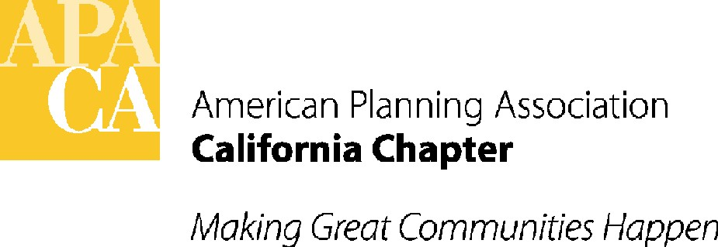

TO: APA CALIFORNIA BOARD OF DIRECTORS

FROM: SANDE GEORGE, EXECUTIVE DIRECTOR

DATE: JANUARY 31, 2018

SUBJECT: APPROVAL OF CHANGES IN 2018 BUDGET & CONFERENCE ITEMS

RECOMMENDED ACTION: Approve recommended changes to the 2018 Budget and approve recommended conference account changes.

BACKGROUND: The 2018 P&L has been updated with the new Chart of Accounts line items recommended by the accountant. Note that the 2017 Conference Profits for the Sections (LI 5720 Section State Conf. Rebate-Prior Year) have been issued and are ready to send to the Sections as soon as the 2017 Conference Profit Report is approved by the Board.

REQUEST FOR CHANGES IN THE 2018 BUDGET: The Board is being asked to consider approval of the following changes to the 2018 Budget in light of the actual 2017 final income and expenses, and to update specified line items:

INCOME:
- LI 4115 National Dues Subventions actual income: -$17,812.54 (lower than budgeted). The budget for 2017 for the subventions from National was $318,000. Only $300,187 was actually sent to the Chapter, resulting in this lower than expected total dues for 2017. The lower amount is partially a result of the flat rate member dues increase being implemented by National later in the year than anticipated. The Board may wish to consider if the 2018 dues estimate of $328,500 should be adjusted.
- LI 4300 Miscellaneous Income – The accountant and bookkeeper are requesting that the Chapter no longer use this or LI 5920 Miscellaneous Expense to the extent possible. They recommend that all income and expenditures be placed into the line items that are closest to the nature of the income and expenditures. That way the Chapter can better monitor these items.

EXPENSES:
- LI 5155 Printing – The bookkeeper recommends renaming this line item “Dues and Subscriptions” to handle the Webinar fees, etc. as this line item hasn’t been used.
- LI 5620 Accounting/Tax Services and LI 5180 Atego Resources – This should be renamed Bookkeeping/Accounting and Tax Services now that the Board has hired Laura Dee to handle bookkeeping. The budget will also have to be increased by $22,000 to pay for Laura Dee’s extra work on the 2017 financials and her new monthly services, estimated to be around 25 hours per month. Note: Laura is paid an hourly rate rather than a flat rate, so this is an estimated budget that could be higher or lower at the end of the year. There will also be a reduction in LI 5180 for Atego Resources to reflect the elimination of her previous bookkeeping services for the Chapter.
- LI 6205 VP Conference Expense – This item is currently used to pay for site visit and other conference expenses incurred by the VP Conferences. The accountant views site visits and other direct conference expenses that the VP Conferences incurs as a conference expense. The Board may wish to move site visit and other VP Conference expenses directly related to the conferences to the conference line items, using LI 6205 only for more Board-related items as the other VP’s do, and reducing this LI to $250 consistent with the other VP expense line item budgets.

CONFERENCE ACCOUNT CHANGES:
The accountant and bookkeeper are recommending that a fourth conference account be added. This fourth conference account would be a flexible account that can be used to pay for expenses for future conferences that cross over into one of the other current three conference accounts before they are closed out. The expenses in this flexible account will be identified by conference year so they can be tracked and added to the appropriate account when opened. The problem is that expenses are being incurred beyond the 3 years that now fit into the three conference accounts.

In addition, the 2018 conference hotel has requested early deposits. $50,000 has already been paid out of Conference Account 3 for the hotel deposits, and another $18,000 is owed for Deene Alongi’s first invoice and expenses. That account is now very low and will need additional seed money to be added to it to pay for expenses that are expected through May and June, before registration and sponsorship monies are available to pick up the remaining conference expenses. The Board may wish to discuss what source of money can be used to pay for 2018 expenses until June as seed money, and to seed the new fourth flexible conference account. Three options are:
- Transfer seed money from the other two conference accounts as needed.
- Use some of the Chapter’s 2017 excess conference profits not needed for checking account cash flow. The Chapter will receive $21,948 in extra conference profits above the $120,000 base profit amount.
- Allocate some combination of the above two options.

ACTION: Approve the suggested changes to the 2018 Budget and conference accounts.

