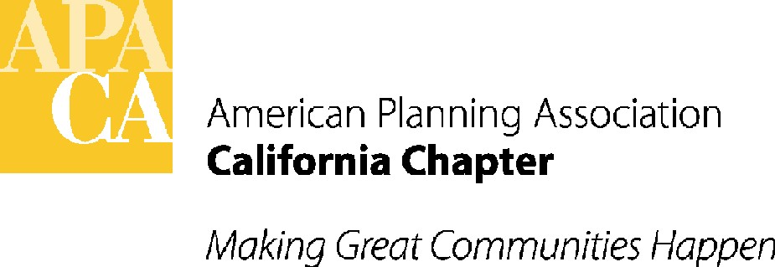

TO: APA CALIFORNIA BOARD OF DIRECTORS

FROM: KRISTEN ASP, VP FOR ADMINISTRATION

DATE: SEPTEMBER 14, 2017

SUBJECT: SECTION PROFESSIONAL BOOKEEPING SERVICES

RECOMMENDED ACTION: Discuss whether the Sections should be using a professional bookkeeper.

BACKGROUND: Per previous Board actions, the Chapter hired a new accounting firm this year. Part of the accountant’s initial charge was to modernize and reorganize the Chapter's bookkeeping and accounting systems, which is nearly completed. That process will, in turn, affect the bookkeeping requirements for the Sections, since everything needs to align throughout the organization. As part of the review of the Chapter’s accounting, we have discussed with the accountant strategies to ensure continued consistent bookkeeping procedures, oversight among the Sections, and improved transparency and accountability.

The Chapter is legally responsible for ensuring that the Chapter’s and the Sections’ finances remain healthy and fiscally sound, as well as for submitting the combined tax returns and paying any taxes owed. If there is inconsistent bookkeeping and oversight, or even a lack of up-to-date financial information available, the Chapter risks an IRS audit, and the Chapter and Sections risk financial loss or illegal activity.

Three strategies have been recommended by the accountant that impact the Sections’ accounting procedures:
- Contract with the Chapter’s accountant for a one-time update and reconciliation of the Sections’ accounting with the Chapter’s. (Part of the draft budget discussion.)
- Switch the Chapter and all of the Sections from the purchase of Quickbooks software as updated, to the OnLine version of Quickbooks. The OnLine version will allow easy assimilation of Section accounts into the Chapter book of accounting. (Also part of the draft budget discussion.)
- Shifting all Sections to the use of a professional bookkeeper, which is the subject of this Board action request. (Three Sections currently use a bookkeeper: Sac Valley, which is looking for a new bookkeeper; Inland Empire which has a family friend providing limited bookkeeping services; and Central Coast, which pays $1,000 a year for quarterly and annual QuickBooks’ reporting to the Chapter, but does not contract for other bookkeeping services.)
The Chapter’s new accountant, if the Sections’ books are reconciled with the Chapter’s and the Sections use the OnLine Quickbooks, would charge an estimated $400 per month per Section billed on an hourly basis.
Note that while the Chapter is interested in consistency and accountability in relation to the Sections' financial matters, and relieving the Sections from bookkeeping responsibilities, the Chapter is not interested in getting involved in the Sections' business and spending decisions. The day-to-day decisions would continue to be made by the Section Boards and Treasurer.
Tricia Stevens developed the following full scope of services for Section bookkeeping services:
Monthly:
Reconcile Bank statements with Quickbooks
Prepare Financial Reports to Section Board
Post bank deposits
Process phoned-in credit card payments
Issue checks
Quarterly:
Prepare Financial Reports, bank statements and reconciliations for CalAPA
Input the information into OnLine Quickbooks (added)
Annual:
Prepare Annual Reports for CalAPA
Issue Forms 1099

QUESTIONS FOR BOARD DISCUSSION:

- Are the Sections agreeable to having Section bookkeeping done by an outside bookkeeper? If so, should we use one bookkeeper for all 8 sections, or should each Section hire a local bookkeeper?

- Is the scope of services above applicable to each Section?

- Should the bookkeeping services include the full scope of services listed above, or a more limited scope such as the quarterly and annual tasks?

- Should the Accounting and Financial Stability Subcommittee develop Section financial oversight procedures, including a requirement that the Section Balance Sheet and Profit & Loss Statement be reviewed by the Section Board at each Section Board meeting, similar to the Chapter procedures?

