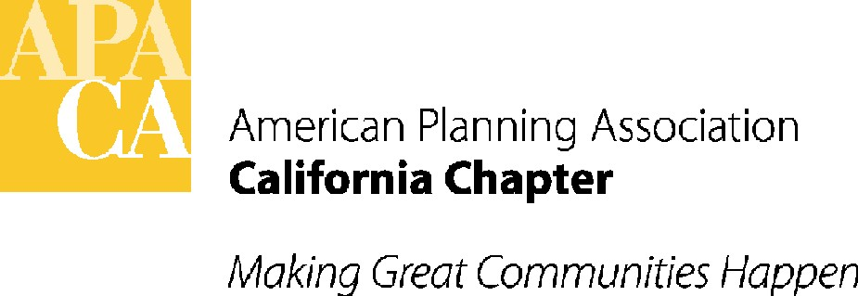

TO: APA CALIFORNIA BOARD OF DIRECTORS

FROM: KRISTEN ASP, VP FOR ADMINISTRATION

DATE: SEPTEMBER 14, 2017

SUBJECT: DISCUSSION AND APPROVAL OF 2018 DRAFT BUDGET

RECOMMENDED ACTION: Discuss and approve 2018 APA budget.

BACKGROUND: APA California this year hired a new accountant who has now updated APA’s books to combine what used to be four books of accounting into one, and update and simplify the accounting process, line items and Profit and Loss Statement. The new draft budget reflects these changes, although we will continue to refine the line items and accounting processes. Previous line items are still in the Profit and Loss Statement as in the 2017 budget, but have been renumbered and placed in appropriate income and expense categories. Unused line items have been removed.

2018 DRAFT BUDGET CHANGES FOR BOARD DISCUSSION:

- Most of the changed line item amounts reflect what is expected to be the actual amount received or spent in 2017 by the end of the year. Those line items include a note that the changed budget amounts are “Based on Actual”.
- There have been a number of new items added due to new, on-going income and expenses. Explanations for these items are in the notes. Several items have been combined into one line item, as described.
- The budget is balanced in revenue and expenses.
- LI 4115 – National Subvention, has been increased to very conservatively reflect the Chapter dues increase anticipated as a result of moving from the previous flat rate of $105 per member per year to a sliding scale based on a percentage of each member’s APA dues, which are based on salary. The Board adopted the 40% rate of the member’s APA National dues. At 40%, about 1/3 of members (5 out of 11 income categories) will see dues go down. The balance of the membership will see an increase ranging from $3 per year for members in the “middle” category, up to $49 per year for members at the top end of the salary scale. LI 4115 has been increased in this draft budget from $318,000 in the 2017 budget to $328,500 in the 2018 budget. This is based on a conservative average $3 dues increase X the current 3478 full members. Should the Chapter receive higher dues in 2018, the Board will review options for these increases as they are received.
- LI 4126 – Conference Profit-Prior Year, is any amount of conference profit not received/budgeted in the year of the conference. For 2017, this includes the 2016 conference profit above the $120,000 minimum profit applied in 2017 minus one last 2016 conference bill in the amount of $1900+ paid in 2017.
- LI 4128 – Extra Conference Profit, is the amount not yet spent from the extra 2016 conference profits allocated to Chapter and Section programs. These unspent funds are carried over into the new fiscal year and will be available to fund programs in 2018. See also the discussion of LI 5660 & LI 5730, below.
- LI 5630 – Reserves/Savings Contributions, will include a one-time increase of $3653, in addition to the ongoing $1200, for a total of $4853 to reserves in 2018. $3653 is the amount of Income over Expenses in the draft budget, and balances the 2018 budget.
- LI 5630 - UBIT Taxes, has been reduced substantially from 2016 and 2017 due to the combination of the previous 4 accounting books into one, and offsetting all ad revenue with all expenses from both the Chapter and Sections.
- LI 5650 – On Line Quickbooks Fee & Section Access, is a new line item to reflect a recommendation from the new accountant to move to the On Line version of Quickbooks. The On Line Quickbooks will allow the Sections and Chapter quarterly tax reports and annual tax report line item amounts to be combined easily through a Class Tracking function, while still allowing separate Section-only reports as well. The monthly OL Quickbooks fee will be between $50 and $65 depending on how many classes are needed.
- LI 5660 and 5730 – Extra 2016 Conference Profit Chapter and Section Project Allocations – DISCUSSION ITEM. These line items are the expense line items for the Chapter and Section “Extra 2016 Conference Profit Allocations” from revenue LI 4128. At its June meeting, the Board decided to make $10,000 available for one-time Chapter program expenditures, such as website upgrades or a scholarship (in LI 5660), and $20,000 available to the Sections (LI 5730), including $4800 for one-time grants to Sections upon request to the Board (up to $600 per Section), and $15,200 for one-time expenditures for multi-section programs or Chapter-wide initiatives that support Sections through programming, training, marketing or other resources. The amount of $1908 was used from the $15,200 for the Go-To-Webinar fee, leaving $13,292 remaining. The Board may wish to discuss options for the one-time expenditures, including the CPF scholarship request. (The CPF scholarship request is included in a separate agenda item.)
- LI 5665 – Section Accounting Update, is another recommendation of the new accountant. The Chapter is responsible for the taxes for the Chapter itself as well as the Sections. Over the years, the many differences between the Chapter and Section accounting revenue and expense line items made reconciling the taxes at the end of the year extremely difficult, time consuming, and subject to error. The accountant has requested that the Chapter and Section line items, and P&L reports, be reconciled. The amount in this line item for the Section Accounting Update is the estimated amount for the new accountant to update the Sections’ current accounting system to match the Chapter’s new accounting system. The draft budget anticipates that the Chapter would pay for the entire amount of these Section updates. The accountant has estimated the average fee for the Section updates to be $750 per Section.
- LI 6330 – DISCUSSION ITEM: The Public Relations program or components of the program have not been funded in several years. The draft budget shows a $3,653 additional deposit to reserves in order to balance the budget. The Board may wish to discuss whether some or all of this amount should be used for one or more public relations strategies.

ACTION REQUESTED OF THE BOARD:

Discuss and finalize the draft budget, and approve the final budget for 2018.

