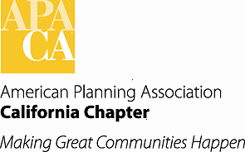

**TO: APA California Board of Directors**

**FROM: Pete Parkinson, AICP, Chapter President**

**DATE: January 27, 2017**

**SUBJECT: Approval of Updated Bylaws**

***Recommended Action: Approve the Updated Chapter Bylaws as reviewed at the October Board meeting.***

At our October Board meeting in Pasadena, the Board reviewed the draft Updated Bylaws as recommended by the Bylaws & Financial Policies subcommittee. A copy of the memo outlining the changes to the Bylaws is attached for reference. The draft updated Bylaws were posted on the Chapter website in late October. No further changes or comments were received.

The updated bylaws have also been reviewed by APA National and found to be consistent with APA’s bylaws.

The updated Bylaws are now ready for final approval by the Board.

Attachments:

Draft Updated Bylaws

Summary memo of September 30, 2016