

INTRODUCTION
The California Chapter of the America Planning Association is pleased to announce the inaugural year for the Great Places in California Awards. A Great Place in California is one that exemplifies character, quality and excellent planning. It can be anywhere from the beach to the mountains, from a large city to a small community. It can be a vibrant downtown, a suburban gathering place, a historic small town, a public park, or preserved open space. Most important, it must be a place where people want to be! Three awards will be selected in 2015. Please see the nomination form and additional information on characteristics of a Great Place in California. Nominations are due by __________.

AWARDS JURY
Seven person jury:

- University representative (rotating)
- Region VI APA representative
- North and South Award Coordinators (2)
- Marketing Director
- Section Director Representative (rotating)
- Other “outside” representative – possibly representative from another state or national president

Great Places in California Nomination Form
Nominating a Great Place in California is easy. Please fill out this form and return to ________ by February 15, 2015 to be considered for 2015 inaugural year awards. Nominations can be for a wide variety of Great Places, including Centers, Corridors, Vistas, Places to Play, Places for People, and Places to Preserve. Please also submit three photos showing the nomination’s outstanding qualities (Jpeg or PDF with 300 resolution).
NAME OF NOMINATION ______________________________________________________________
List four or five important features or reasons that make this nomination outstanding and worthy of a Great Place in California. Please be as specific as possible and see accompanying list of characteristics and criteria to consider. Awards need not be specific to a category but consider the following types of Great Places in your nomination. The process for selection is attached.
 | - Great Vistas |  | - Great Places to Play | - Great Places for People
 | - Great Corridors |  | - Great Centers | - Great Places to Preserve
1. |  | _______________________________________________________________________________
 |  | _______________________________________________________________________________
 |  | ________________________________________________________________________________
2. |  | ________________________________________________________________________________
 |  | ________________________________________________________________________________
 |  | ________________________________________________________________________________
3. |  | ________________________________________________________________________________
 |  | ________________________________________________________________________________
 |  | ________________________________________________________________________________
4. |  | ________________________________________________________________________________
 |  | ________________________________________________________________________________
 |  | ________________________________________________________________________________
5. |  | ________________________________________________________________________________
 |  | ________________________________________________________________________________
 |  | ________________________________________________________________________________
Name and Contact Information for Nominator:
Name: ___________________________________________________________________________
Contact Information: _______________________________________________________________

Additional Information for Great Places in California
Characteristics of a Great Place in California
A Great Place in California is one that is memorable to the community and individuals and creates a strong sense of place. There is a wide variety of places that can be considered great, including:
Great Vistas | Great Places to Play | Great Places for People
Great Corridors | Great Centers | Great Places to Preserve

Characteristics to consider (not all may apply):
- Contribution to a resident's day-to-day quality of living, encouraging human contact and social activities
- Multi-modal transportation (i.e. pedestrians, bicyclists, transit, drivers)
- Visually interesting design and architectural features
- Sustainable design
- Safe environment that is welcoming for all
- Unique or special character, such as a reflection of local culture or history
- Extraordinary open spaces that preserve the natural environment

Process for Selection
2015 is the inaugural year for the Great Places in California Award. Three Great Places will be selected. Nominations are due by February 15, 2015. Nominations can be submitted to electronically. A Great Places Awards Jury will be convened shortly after the nominations are received, and Awards will be announced in May 2015.
Criteria for Selection (not all may apply). The Jury will consider the following criteria for selection of the awards:
- What is the form and composition of the Great Place? How does the Great Place fit in its natural setting and the surrounding environs? How does the Great Place foster social interaction and promote human contact? How is a sense of community and neighborliness created? Is the Great Place perceived as safe for children?
- What is the character and personality of the Great Place? What makes the Great Place stand out? What makes it extraordinary or memorable? What elements, features, and details reflect the community's local character and set the Great Place apart? Does the Great Place provide interesting visual experiences, vistas, natural features, or other qualities? How does the architecture of the buildings, landscape and/or streetscape create visual interest? What is the history of the space, and how is it remembered or passed on from one generation to the next?
- What sustainable practices apply? How does the Great Place respond to the growing threat of climate change? (e.g., local tree cover mitigating heat gain, protect air and water quality, manage stormwater runoff)? Is there any form of "green infrastructure"?
- What are the great features and elements? How does the Great Place accommodate pedestrians or others whose access to the space is by transit, bicycles, or other means? Is the space welcoming to those with physical disabilities or others with special needs? Does it provide interesting visual experiences, vistas, or other qualities? Is public art incorporated into the Great Place?
- What are the activities and sociability attributes? What activities make the Great Place attractive to people and encourage social interaction (commerce, entertainment or performances, recreational or sporting, cultural, markets or vending, exhibits, fairs, festivals, special events, etc.)? How does this Great Place encourage use by a diverse cross section of the public? Is this Great Place accessible to all people and income levels?

Examples of Great Places in California
Following are examples of places in California that received the Great Places in America award, to be used as a guide. While these examples are urban areas, we highly encourage small communities and rural areas to apply!

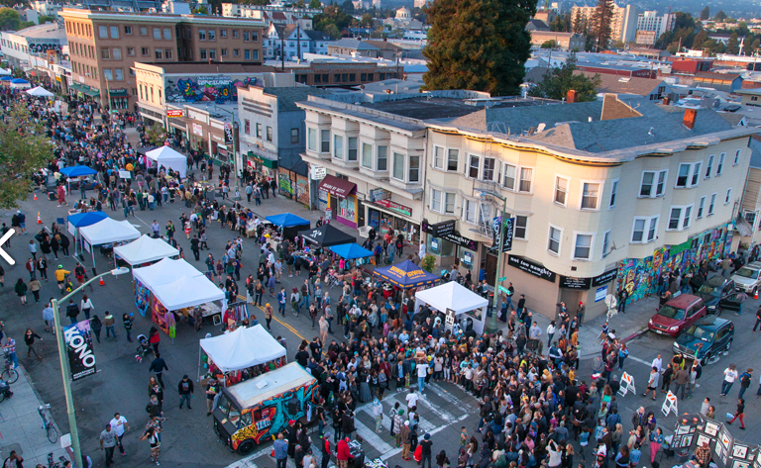
Uptown, Oakland. Uptown incubates the home-grown, artistic, and entrepreneurial spirit unique to Oakland. The neighborhood has experienced significant revitalization over the last 15 years, transforming an area dominated by underutilized parking lots into the Bay Area's premier arts and entertainment district. The neighborhood was officially designated as the "Arts and Entertainment District" by the City of Oakland in 2009.

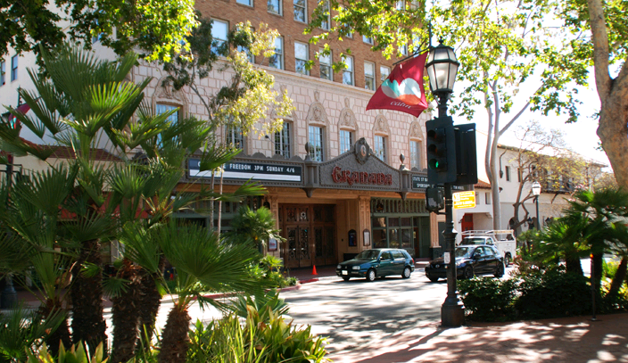
State Street, Santa Barbara. Running through the heart of downtown Santa Barbara, State Street has served as the social, economic, and cultural center of the city and southern coast for over 150 years. Officially named in 1850 to honor California's recently declared statehood, State Street runs from the historic Stearns Wharf, to the waterfront district and continues through the center of downtown. Its unique Hispanic architectural style and landscaping, pedestrian amenities, proximity to the Pacific Ocean, views of the Santa Ynez Mountains, and cultural sites provide 24-hour activities for residents and visitors.

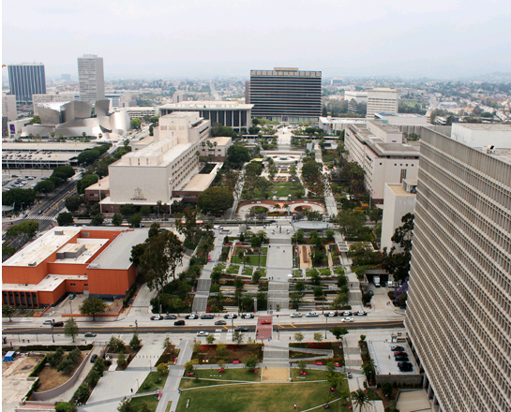
Grand Park, Los Angeles. Today an aspirational vision of a civic and cultural center for downtown Los Angeles, proposed more than a century ago by the pioneering planning theorist and landscape architect Charles Mulford Robinson, has been realized through the redevelopment of Civic Center Mall as Grand Park. Extending from the Music Center to City Hall, Grand Park not only is one of Los Angeles's most popular places for daily exercises, lunch breaks, and family activities, it also is a hub for surrounding communities of historic Chinatown, Little Tokyo, El Pueblo, and the Old Bank district.

