AGENDA ITEM

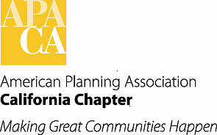

TO: APA California Chapter Board

FROM: Kristen Asp, AICP, Vice President of Administration

DATE: January 16, 2015

SUBJECT: California Great Places

Background:

On our Executive Board call on December 5, 2014, the Board moved, seconded and passed to approve the application form, criteria, and jury for APA California’s new Great Places program, with the addition of an introduction to inform members about the program.

Francine is developing a form so that we are able to have nominations filled out and submitted online. The current logo graphics are a bit grainy and we are working to resolve with Dorina’s guidance. Once resolved will be able to get the program up and running in a few days. Currently, we are working toward a February 15, 2015 deadline. To publicizes, we will work with Marketing and Membership and Public Information to get the work out in CalPlanner, website, etc.

Attachment:

Great Places Introduction, Nomination Form and Criteria

