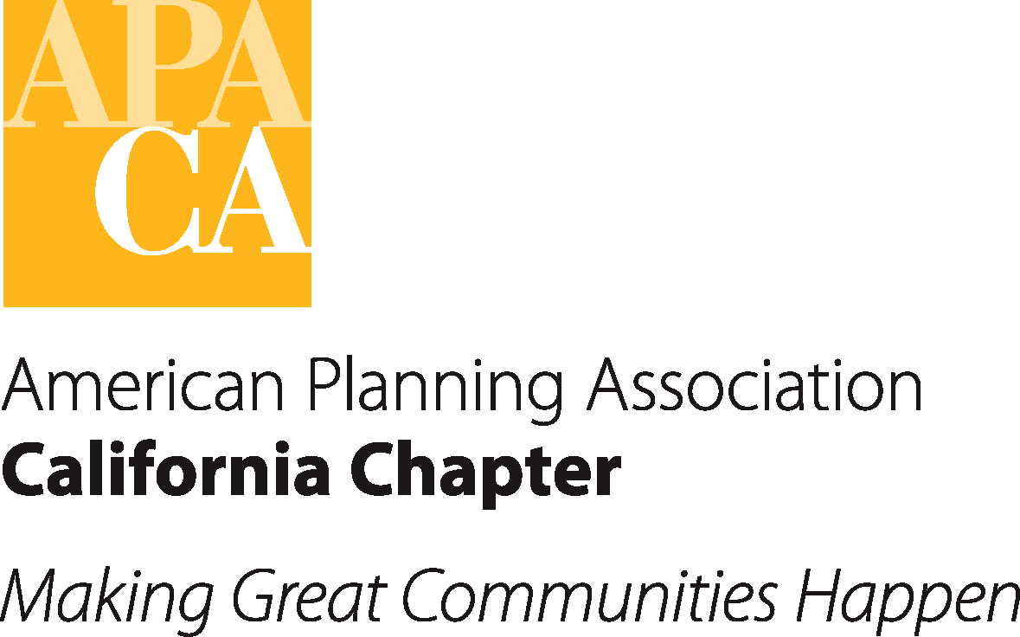

HISTORICAL CONFERENCE PROFITS

YEAR | LOCATION | PROFIT
2014 | Disneyland | $ 35,815
2013 | Visalia | $136,737
2012 | Rancho Mirage | $140,000
2011 | Santa Barbara | $131,000
2010 | La Costa | $ 78,782
2009 | Squaw Creek | $ 52,690
2008 | Hollywood | $143,036
2007 | San Jose | $216,216
2006 | Orange | $142,258
2005 | Yosemite | $115,451
TOTAL |  | $1,191,985

AVERAGE PROFIT/ALLOCATIONS
10-Year Average – Total Net Profit | $119,198
10-Year Average – State Share (40%) | $ 47,679
10-Year Average – Host Share (40%) | $ 47,679
10-Year Average – Section Share (20%)  ($23,840 Divided by 7) | $ 3,406

