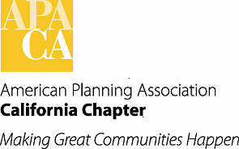

TO: APA California Chapter Board

FROM: Kristen Asp, AICP, Vice President of Administration

DATE: June 17, 2016

SUBJECT: Financial Policy for funding Chapter Reserve Account and Conference Profits

Recommended Action:

Establish subcommittee to develop financial policy

Background:

As we continue to monitor our Association’s financial situation regularly, and in particular address the needs of the Chapter’s reserves, the Board needs to develop a policy for funding reserves as it relates to annual conference profits. Discussion will include a long-term plan to contribute funds back to Chapter reserves when the conference profits exceed an established threshold. Details will be developed to distribute these additional monies incrementally between Chapter reserves and Chapter sections. It is suggested that this be an eight year cycle so it would apply to a conference in every section and be revisited/revised appropriately after one complete cycle.

