GREAT PLACES IN CALIFORNIA
FOR DISCUSSION PURPOSES:
This document provides a brief description of existing APA Great Places programs, both at the National and State level followed by recommendations for creating a Great Places in California program to begin in 2014 with Great Places in California to be announced in the Spring of 2015 (consistent with the current understanding of guidelines set by APA for State level Great Places programs).
BACKGROUND:
Great Places in America
APA's flagship program celebrates places of exemplary character, quality, and planning. Places are selected annually and represent the gold standard in terms of having a true sense of place, cultural and historical interest, community involvement, and a vision for tomorrow. APA Great Places offer better choices for where and how people work and live. They are enjoyable, safe, and desirable. They are places where people want to be — not only to visit, but to live and work every day. America's truly great streets, neighborhoods and public spaces are defined by many criteria, including architectural features, accessibility, functionality, and community involvement. https://www.planning.org/greatplaces/
The program began in 2007 with Great Neighborhoods and Great Street categories. Great Public Spaces was added in 2008. Below are characteristics that APA lists for each of their three “Great” categories. See Exhibit A for nomination form.
Great Neighborhoods (Characteristics)
- Has a variety of functional attributes that contribute to a resident's day-to-day living (i.e. residential, commercial, or mixed-uses).
- Accommodates multi-modal transportation (i.e. pedestrians, bicyclists, drivers).
- Has design and architectural features that are visually interesting.
- Encourages human contact and social activities.
- Promotes community involvement and maintains a secure environment.
- Promotes sustainability and responds to climatic demands.
- Has a memorable character.

Great Streets (Characteristics)
- Provides orientation to its users, and connects well to the larger pattern of ways.
- Balances the competing needs of the street — driving, transit, walking, cycling, servicing, parking, drop-offs, etc.
- Fits the topography and capitalizes on natural features.
- Is lined with a variety of interesting activities and uses that create a varied streetscape.
- Has urban design or architectural features that are exemplary in design.
- Relates well to its bordering uses — allows for continuous activity, doesn't displace pedestrians to provide access to bordering uses.
- Encourages human contact and social activities.
- Employs hardscape and/or landscape to great effect.
- Promotes safety of pedestrians and vehicles and promotes use over the 24-hour day.
- Promotes sustainability through minimizing runoff, reusing water, ensuring groundwater quality, minimizing heat islands, and responding to climatic demands.
- Is well maintained, and capable of being maintained without excessive costs.
- Has a memorable character.

Great Public Spaces (Characteristics)
- Promotes human contact and social activities.
- Is safe, welcoming, and accommodating for all users.
- Has design and architectural features that are visually interesting.
- Promotes community involvement.
- Reflects the local culture or history.
- Relates well to bordering uses.
- Is well maintained.
- Has a unique or special character.
Great Places in New Jersey
This program began in 2012 with Great Neighborhoods, Public Spaces and Streets. Great Downtowns were added in 2013. Announcements of the Great Places in New Jersey are made in October, which coincides with APA’s announcement of Great Places in America. See Exhibit B for the nomination packet. This program has similar criteria to Great Places in American, with the added Downtown criteria.
Great Places in North Carolina
This program also began in 2012. In 2014 North Carolina recognized the following Great Places in North Carolina categories: Great Main Street, Great Public Places, and Great Main Streets in the Making. They had a “People’s Choice” category and a “Professionals’” category. These Great Places were announced in May 2014. The image below is a snapshot of the video that was created to solicit nominations for the 2014 Great Places in North Carolina (link provided).
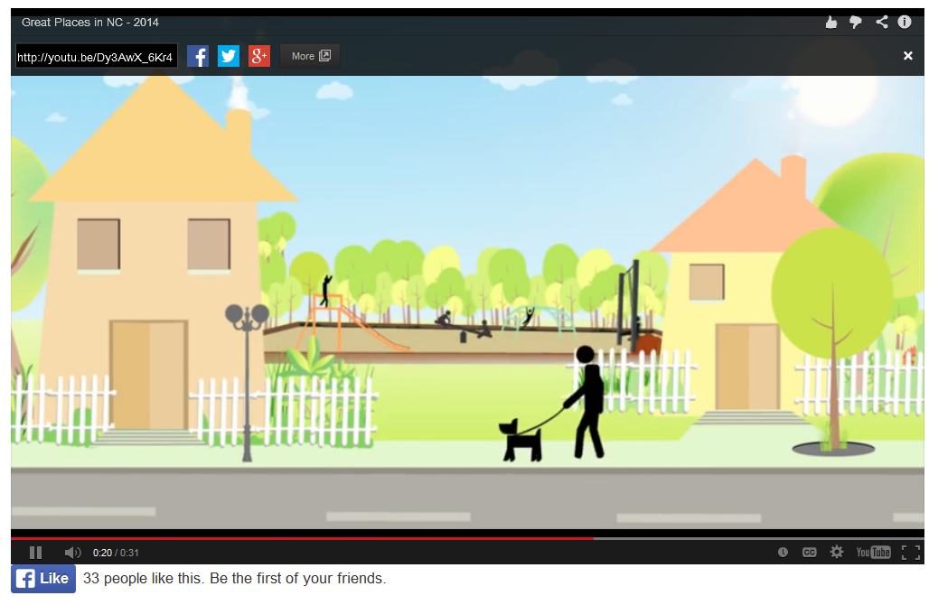
http://youtu.be/Dy3AwX_6Kr4
WHAT MAKES A GREAT PLACE IN CALIFORNIA?
Types of Great Places
Great Places in California could celebrate great Neighborhoods, Streets and Public Spaces like the APA program, however this may get confusing. Great Places in California could recognize Downtowns, Main Streets or even “Great Places in the Making” like other State programs. The following is a list of other types of great places that could be California specific.
Great Vistas Great Places to Play
Great Corridors Great Places for People
Great Centers Great Places to Preserve
However if we don’t provide categories, especially in the inaugural year of Great Places in California, we may be surprised by the results and can further define the program based on the nominations we receive.
Number of Great Places
There are great places throughout California, so perhaps rather than defining “what” great places are, we decided how many awards would best promote the goals of the program (below)
The board may choose to award one great place (for instance “California’s Gold” in Honor of Huell Howser), one award in a few specific categories (see above) or one award in each of the eight Sections. However, honoring eight great places a year (geographically distributed or not) may eventually dilute the prestige of the Great Places in California. It may also become confused with the strong Awards program that we have today.
Program Goals
1) To promote APA CA and the planning profession, both internally and externally throughout California.
2) To highlight and honor best place-making practices in California.
3) To complement (not compete) with the Great Places in America program.
GREAT PLACES IN CALIFORNIA - PROPOSED PROCESS & TIMELINE
Process
There are a number of ways to choose the Great Places in California. Below are three options. There are of course iterations of these options that could be discussed in more detail by a future Great Places committee.
1) “People’s Choice” (Web-based voting done either by members or by anyone.) This process does promote planning and place-making to a wider audience, however it may lead to “campaigning” or other unintended consequences of an open voting process.
2) State Jury The Great Places in California committee would select a state-wide jury, similar to our current jury process for the annual APA CA awards. The Jury would meet in person to select the 8 great places in California.
3) Section Jury Rather than one statewide jury, each of the Sections could fold the Great Places in California process into their existing Awards process by having their award’s jury (or even each section board) choose one of the Great Places in California. As long as the criteria (below) was followed and the processes were similar and each Section had their selection made by a certain date – the selections could be announced by APA CA and promoted/awarded by each Section.
Timeline
September 2014 – Great Places in California Announced at APA California Conference
October 2014 – Nomination criteria and forms available on APA California’s website
January 2015 – Nominations Due
March/April 2015 – Jury and/or Online “People’s Choice” Vote
May 2015 – Inaugural Great Places in California Announced (and celebrated at each Section Award’s Ceremony)
June 2015 – Evaluation of Program
September/October 2015 – Announce Great Places 2015 process (and any modifications to the program)

GREAT PLACES IN CALIFORNIA - PROPOSED CHARACTERISTICS & CRITERIA
Characteristics
- Has a variety of functional attributes that contribute to a resident's day-to-day living (i.e. residential, commercial, mixed-uses, institutional, and/or recreational).
- Accommodates multi-modal transportation (i.e. pedestrians, bicyclists, transit, drivers).
- Has design and architectural features that are visually interesting.
- Encourages human contact and social activities.
- Promotes community involvement and maintains a secure environment.
- Promotes sustainability and responds to climatic demands.
- Is safe, welcoming, and accommodating for all users.
- Reflects the local culture or history.
- Has a unique or special character.

Criteria
Description of the Great Place
- Where is the Great Place located: in a downtown, urban area, suburb, exurban area (i.e., on the fringes of a metropolitan area), village, or small town?
- What is the Great Place’s location, its physical extent, and layout? What are the boundaries? Are these boundaries formal, defined by an institution or jurisdiction (i.e., districts or other political boundaries, neighborhood associations, other entities) or is the Great Place defined informally?
- What is the layout (e.g., grid, curvilinear) of the streets? Is there street connectivity; is it easy to get from one place to another by car, foot, or bike within or beyond the neighborhood without going far out of one's way?
- What is the mix of residential, commercial, retail and other uses?
- What activities and facilities support everyday life (e.g., housing, schools, stores, parks, green space, businesses, churches, public or private facilities, common streets, transit, etc.)?
- Is there diversity amongst the people who live, work, or plan in the Great Place, including economic, social, ethnic, and demographic?
- How has a plan or planning contributed to or sustained the character of the Great Place? Or did it form more organically and not through a formal planning process?

Form and Composition (not all may apply)
- How is the Great Place fitted to its natural setting and the surrounding environs?
- How does the Great Place foster social interaction and promote human contact? How is a sense of
community and neighborliness created?
- Does the Great Place promote security from crime, and is it perceived as safe? How are streets made safe for children and other users (e.g., traffic calming, other measures)?

Character and Personality (not all may apply)
- What makes the Great Place stand out? What makes it extraordinary or memorable? What elements, features, and details reflect the community's local character and set the Great Place apart?
- Does the Great Place provide interesting visual experiences, vistas, natural features, or other qualities?
  - How does the architecture of the buildings, landscape and/or streetscape create visual interest? Are the buildings, landscape and/or streetscape designed and scaled for pedestrians?
  - What is the history of the space, and how is it remembered or passed on from one generation to the next?
  - How is local history retained, interpreted, and used to help create a sense of place?
  - How has the Great Place adapted to change? Include specific examples.
- Is there a sense of importance about the Great Place? What characteristics or qualities contribute to this?
- What makes this space special and worthy of designation as a Great Place?

Neighborhood Environment and Sustainable Practices (not all may apply)
- How does the Great Place respond to the growing threat of climate change? (e.g., local tree cover mitigating heat gain)?
- How does the Great Place promote or protect air and water quality, protect groundwater resources if present, and minimize or manage stormwater runoff? Is there any form of "green infrastructure"?
- What measures or practices exist to protect or enhance local biodiversity or the local environment?

Features and Elements (not all may apply)
- What landscape and hardscape features are present? How do they contribute to the unique or special nature of the Great Place?
- How does the Great Place accommodate pedestrians or others whose access to the space is by transit, bicycles, or other means? Is the space welcoming to those with physical disabilities or others with special needs?
- How does the Great Place utilize existing topography, vistas, or geography? Does it provide interesting visual experiences, vistas, or other qualities?
- How are murals or other public art incorporated into the Great Place?

Activities and Sociability (not all may apply)
- What activities make the Great Place attractive to people and encourage social interaction? (Commerce, entertainment or performances, recreational or sporting, cultural, markets or vending, exhibits, fairs, festivals, special events, etc.)
- How do people interact with one another? Does the Great Place encourage communication or interaction between strangers?
- How does this Great Place encourage use by a diverse cross section of the public?
- Is this Great Place accessible to all people and income levels?

NEXT STEPS
Committee
Set up a committee of board members to work on the details based on the recommendations of the board.

Details
Such details could include, but are not limited to:
1) Create Nomination Forms and Process
e.g. Can a Great Place be nominated more than once? If rejected, can they be re-nominated in successive years, or would you want there to be a period between one nomination and the next?
2) Revise Criteria
e.g. The various criteria discuss architecture and urban design, but not landscapes or cultural landscapes. It seems to me that if we include architecture by definition, then we should also express landscape design as well.
3) Establish Marketing Strategy
e.g. Work with APA (National) to use proper logo and marketing materials.

