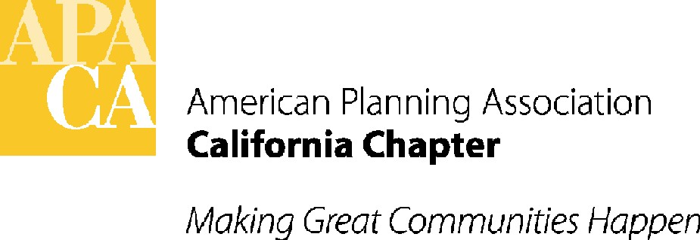

ACTION MINUTES

APA California Board Meeting
APA Conference Line

June 5th, 2015
ATTENDEES:
EXECUTIVE BOARD
President Hing Wong, AICP
VP, Public Information Marc Yeber
VP, Professional Development Terry Blount, AICP
VP, Administration Kristen Asp, AICP
VP, Conferences Betsy McCullough, AICP
VP, Membership & Marketing Virginia Viado
VP, Policy & Legislation John Terell, AICP
Past President Brooke Peterson, AICP
Commission and Board Representative Scott Lefaver, AICP

SECTION DIRECTORS
Central Ralph Kachadourian (in place of Ben Kimball)
Central Coast Dave Ward, AICP
Inland Empire Chris Gray, AICP
Los Angeles Marissa Aho, AICP
Northern Andrea Ouse, AICP
Orange County Dana Privitt, AICP
Sacramento Valley Trisha Stevens, AICP
San Diego Gary Halbert, AICP

APPOINTED MEMBERS AND GUESTS
Technology Director Aaron Pfannenstiel, AICP
APA Director, Region VI Kurt Christiansen, AICP
AICP Commissioner, Region VI Marissa Aho, AICP
Chapter Historian – Northern Steve Preston, FAICP
Chapter Historian – Southern Larry Mintier, FAICP
California Roundtable President Woodie Tescher

STAFF
Stefan/George – Executive Director/Lobbyist Sande George
Stefan/George – Director of Administration Tom Stefan
Stefan/George – Exec Assistant/Lobbyist Lauren De Valencia

ACTION ITEMS FROM BOARD MEETING

- CALL TO ORDER
President Hing Wong called the meeting to order on Friday, June 5th at 9:00 am.
- APPROVAL OF CONSENT ITEMS - VOTE
Approval of the Consent Items: Hing Wong asked to add time at the end of the agenda for any appointed members that wished to speak. The Board moved, seconded and passed to approve the Agenda, with the addition above, Membership Report and 2015 Financials. Unanimous vote.
Approval of January 2015 Minutes: The Board moved, seconded and passed to approve the January 2015 Board Meeting/Retreat minutes. Unanimous vote.
- ACTION ITEMS
D. Great Places Action: Kristen Asp notified the Board that the winners of the California Great Places Awards are up the APA California website. She asked the Board for feedback on how the winners should be acknowledged at the Conference. Hing Wong and Betsy McCullough will discuss how best to do this.
Marc Yeber noted that the award is a certificate rather than a physical award so he asked that consideration be given to framing and matting the certificate to present to the winners.
F. Conferences
2016 Conference Theme: Betsy McCullough asked the Board to approve the 2016 Conference theme, which will be "Crafting our Future: The Art of Planning”.
VOTE: The Board moved, seconded and passed to approve the 2016 Conference theme. Unanimous vote.
2017 Conference Co-Chairs: The Sacramento Valley Section requested that the Board approve the co-chairs for the 2017 conference. Typically the co-chairs for this conference would not be presented for approval until January 2016. However, the Section would like to get moving earlier and the Board’s approval of their proposed co-chairs is a key aspect. Betsy McCullough asked that the following three people be approval as the 2017 Conference Co-Chairs:
- Bob Lagomarsino, AICP
- David Kwong
- Jeannie Lee, JD, AICP
VOTE: The Board moved, seconded and passed to approve the 2017 Conference Co-Chairs. Unanimous vote.
H. Legislative Platform Approval: John Terell noted that the 2015 Legislative Platform has been updated with statements related to housing and water policy. There was a request to remove a statement relating to inclusionary housing. Because there are no specific bills currently in the legislature related to this, John is supportive of this change and asked for the Board’s approval.
VOTE: The Board moved, seconded and passed to approve the 2015 Legislative Platform with the changes noted above. Unanimous vote.
K. Ballot Slate Approval: Brooke Peterson asked the Board to approve the ballot slate for the 2015 Board of Directors Elections. The slate is as follows:
President‐Elect
Pete Parkinson
Vice President for Administration
Kristen Asp
Vice President for Public Information
Marc Yeber
Vice President for Marketing and Membership
Greg Konar, Virginia Viado and Dave Ward
Betsy McCullough noted that there are still many categories with only one person running. Brooke let the Board know that the Elections Committee made every attempt to place more than one person on the ballot. The Committee even reached out to others they thought would make good candidates for the categories but those people weren’t interested in running at this time.
Woodie Tescher noted that it might be helpful to market the upcoming elections beyond just an eblast. The Board could consider placing ads in Cal Planner and online.
Tom Stefan explained that in the past the elections used to be marketed on membership invoices, Cal Planner and other materials that the membership would receive, however it never generated a response.
VOTE: The Board moved, seconded and passed to approve the 2015 Ballot Slate as noted above. Unanimous vote.
N. Planning Pioneer and Planning Landmark Awards Programs: During deliberations on this year’s nominations for the Planning Pioneer and Planning Landmark Awards, the Chapter Co-Historians and the review panel discussed several concerns members have with the how the awards nomination and selection process operates and how the National and California programs relate to one another. This has led to an ongoing discussion among an expanded panel of APA California members to develop recommendations for revising the program. This expanded panel includes Larry Mintier, Steve Preston, former Chapter President Janet Ruggiero, Northern Section Historian Juan Borrelli, Inland Empire Section Historian Gustavo Gonzalez, Los Angeles Region Planning History Group member Ken Bernstein, Vivian Kahn, and George Osner. There is consensus among panel members that criteria for the Pioneer and Landmark Awards the Chapter is using in California for recognizing important achievements focus too much on national significance and not enough on California significance.
Steve Preston and Larry Mintier recommend that the Board adopt specific Chapter criteria for the Pioneer and Landmark Awards focused specifically on California significance. This would still allow for winners in the California awards program to be forwarded to National to complete based on their national significance.
A simple editing of the National criteria to focus on California would accomplish this objective and could be implemented by the Chapter Board immediately, allowing for dissemination to the California Chapter membership for use in 2016.
Steve Preston noted that the Bylaws might need to be updated with respect to the language in the Historian Section for this award to make it consistent with changes made today. He will make some recommendations later on.
VOTE: The Board moved, seconded and passed to adopt the specific Chapter criteria for the Pioneer and Landmark Awards focusing specifically on California significance. Unanimous vote.
P. Retreat Summary: Hing Wong asked the Board to review the Retreat Summary specific to the items that they are responsible for. The next step will be to come up with one or two items from the list of actions that they feel they can accomplish this year. Hing would like those items to be sent to him by the end of June and then he will work to put together a discussion for the next Executive Board conference call.
Note that the next Executive Board Conference call will be on August 7th at 1:30 pm.

- ADJOURNMENT
The Board Meeting was adjourned at 12:30 pm.

