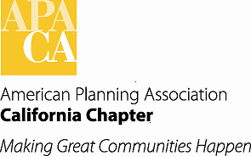

**TO: APA California Chapter Board Meeting**

**FROM: Betsy McCullough, AICP, Vice President Conferences**

**DATE: June 17, 2016**

**SUBJECT: AMENDMENTS TO CHAPTER BYLAWS PROPOSED BY VP CONFERENCES**

Recommended Action:

*Accept for posting on the Chapter website the revisions in the attached draft of the Chapter Bylaws related to adding the position of Conference Programs Coordinator.*

Background:

With the Chapter Board approval of the addition of the Conference Programs Coordinator position in January 2016, amendments to the Chapter Bylaws to enable this position to be filled are proposed. Amendments to the Bylaws require a 30-day notice on the Chapter website before action by the Chapter Board. If the Board approves these amendments for posting, a vote to approve could be taken during the October Board meeting at the conference or via email vote of the Board.

The amendments to enable the new Coordinator position both propose to add Section 6.27 to Article V Duties of the Chapter Board of Directors, and to amend the duties of the VP Conferences (Section 6.10) to add oversight of the Conference Programs Coordinator, and the duties of the Statewide Programs Coordinator who reports to the VP Professional Development (Section 6.19) to shift conference program duties to the new Coordinator position. The Board report from January explains the need for this new position reporting to the VP Conferences. (*“A Conference Programs Coordinator could work with the CHC Programs Committee on: guiding them through the session solicitation process and selection process; finding topics for, and setting up the pre-conference session topics; and working with the moderators of those; perhaps work with Mobile Workshops development; and work with the sessions that we will record for future educational use and revenue.”)*

The attached includes the proposed new Section 6.27 and the proposed revisions to Sections 6.10 and 6.19.