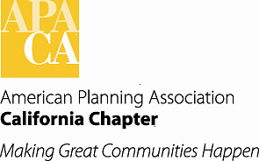

**TO: APA California Chapter Board Meeting**

**FROM: Betsy McCullough, AICP, Vice President Conferences**

**DATE: June 17, 2016**

**SUBJECT: REVISED 2016 CONFERENCE BUDGET**

Recommended Action:

*Review and accept the latest version of the 2016 Conference Host Committee’s budget.*

Background:

Starting in 2016, the Conference Host Committee (CHC) is using a Standard Line Item Budget as provided to them in the Conference Handbook. The intent is to have line items always available in a budget format that the CHC can use, or be aware of why they are not using them. The Standard Line Item budget was developed to counteract ‘budget format creep’ where a new CHC would use the budget prepared by the prior year’s CHC, not realizing that Line Items they needed had been dropped out because a prior CHC did not need them or were not aware they were necessary.

In January 2016 the 2016 CHC Co-Chairs presented an early draft budget to the Board for approval. There were a number of comments from Board members about adequate food at events, the overall schedule, and the amount of profit to be aimed for. Many conference-specific costs were not known at that time. The Board also entered into a debate about whether conference registration fees should be raised in 2016 (the decision was made in April after a Board vote to raise fees in some categories). Some further refinements may be done in the Mobile Workshop revenue and expense Line Items since the MW costs and fees were identified just prior to registration opening.

The attached budget reflects $120,000 as the sponsorship goal. It includes better estimates of food costs and site-specific costs at the venue. It should be noted that the CHC is very cost-conscious and is attempting to control costs in all ways possible while providing an exciting and quality experience for attendees.