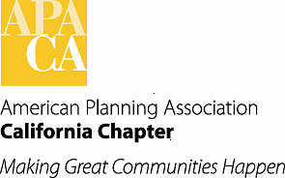

TO: APA California Chapter Board

FROM: Virginia M. Viado, Vice President of Marketing and Membership

DATE: September 13, 2014

SUBJECT: Marketing and Membership Programs Status

Recommended Actions:

- Receive verbal update of Membership Inclusion, University Liaison and Young Planners Group (YPG) programs.

- Discuss and recommend names for a new YPG Coordinator.

Background:

The following programs under the VP Marketing and Membership portfolio are in place to focus on efforts of key interest groups related to retention of existing members, as well as market the benefits the Chapter provides to planning professionals, academics, students, and others interested in our profession to gain new members. The following appointed coordinators will provide a brief update on their respective programs.

Membership Inclusion: Anna Vidal (South) and Miroo Desai, AICP (North).

University Liaison: Julia Lave Johnston

Young Planners Group: Ted Holzem

Fiscal Impact:

None at this time.

