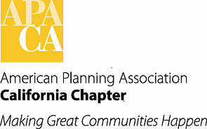

TO: APA California Chapter Board

FROM: Virginia M. Viado, Vice President of Marketing and Membership

DATE: October 3, 2015

SUBJECT: Marketing and Membership Programs Status

Recommended Actions:

- Receive and file reports provided on the Membership Inclusion, University Liaison and Young Planners Group (YPG) programs.
- Discuss status of PR Program and efforts to move the program forward in 2015.
- Receive report on inaugural year of the Great Places in California program and discuss potential awards policy language.

Background:

Programs under the VP Marketing and Membership portfolio are in place to focus on efforts of key interest groups related to retention of existing members, as well as market the benefits the Chapter provides to planning professionals, academics, students, and others interested in our profession to gain new members. The following appointed coordinators have provided or will provide information on activities from their respective programs from 2015 and for moving forward for 2016:

Membership Inclusion: Anna Vidal (South) and Miroo Desai, AICP (North);

University Liaison: Julia Lave Johnston

Young Planners Group: Nina Idemudia

Fiscal Impact:

None at this time.

APA CA Membership Inclusion Directors’ Update
October 2015

- Sections Updates:
We still have a vacancy in Central Section. We were able to fill the Inland Empire Section with Miguel Angel Vazquez and San Diego with Marcus Bush. All the sections have been busy either preparing for upcoming events or have had events throughout the year. Northern Section has had Planners of Color mixers, given presentations on Planning at high schools and organized a CM-credited workshop for planners on “Communicating and Collaborating with the Public through Visual and Spatial Knowledge”. Central Coast have continued with their series “Movies in my Back Yard” and showing planning related movies. Los Angeles had a Mentorship program that is ongoing. Sacramento and San Diego have had a speakers’ series. Finally, James Rojas has won the Inland Empire Section and the State Planning Advocate award and we have also applied for APA National award. He will be the first planner of color to win the Planning Advocate award.

- Diversity Summit 2015
The topic is Gentrification Mosaic: Conversations on Displacement of Economic and Social Capital. The speakers are confirmed: Vikrant Sood moderator, Karen Chappelle (Professor, UC Berkeley), Cindy Chavez (Board of Supervisors, Santa Clara County), Laura Simpson (Planning Director, City of Concord), Pilar Lorenzana-Campo, Policy Director, SV@Home; and Remy De La Peza (Policy Counsel, Little Tokyo Service Center). The panel will explore these issues with local examples, share existing assessment, policy and implementation tools to address displacement risks, and identify effective best practices at the local and regional level.

- APA National’s Ambassador Program
Miguel Angel Vazquez is on the Diversity Taskforce with APA National and they have revived the Ambassador Program. It will be a one year pilot program and California has been chosen to participate in the program as it has Diversity Directors on its Section Boards and the Northern Section has been carrying out the Ambassador program at the local level. The Taskforce has three goals for the pilot: to increase the diversity of our membership, to promote planning to the broader public, and to provide more opportunities for volunteerism. There will be a report to the APA National Board at the April 2016 conference in Phoenix. All the Membership Inclusion Directors as well as Miroo and Anna will be providing support to all the ambassadors.

Young Planners Group/Young and Emerging Professionals Update
October 2015

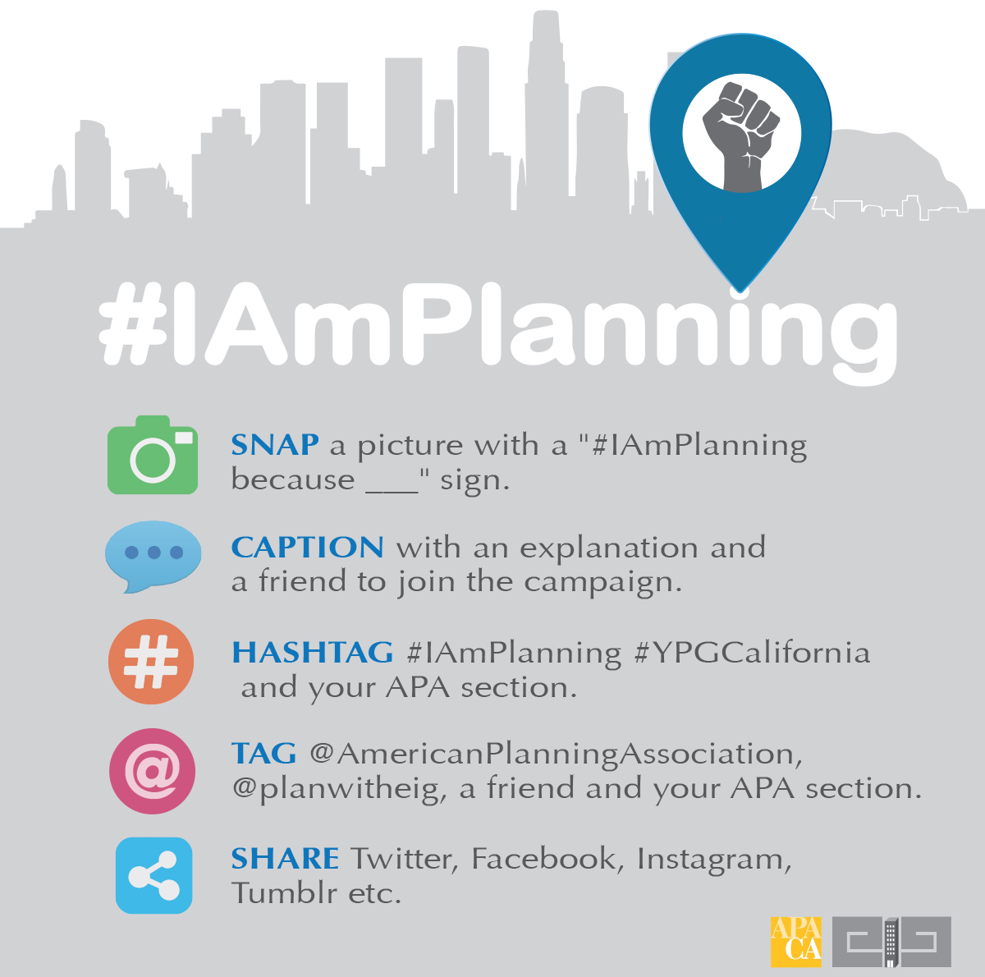
On October 1st, YPG California, in collaboration with EIG Group, launched the #IAmPlanning Social Media Campaign. This campaign will give young planners, both APA members and non-members, the opportunity to share the reasons they chose the planning profession. The purpose of the campaign is to highlight the different faces and backgrounds of young planners across the nation.
How It Works:

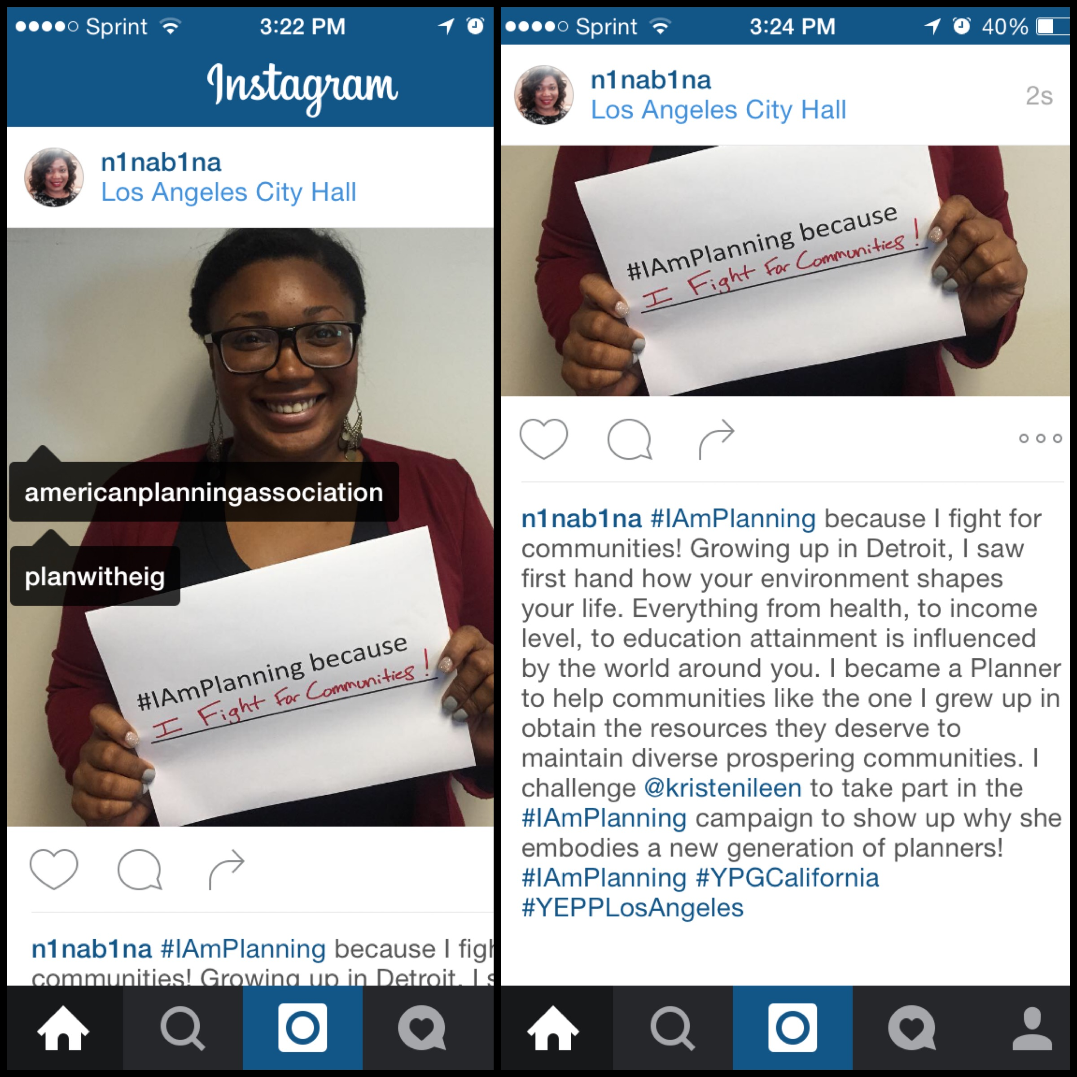
Example:

I would love your help in making this campaign a success! Please use your platform to generate buzz about the #IAmPlanning Campaign and encourage your network to participate. The instructions above can be downloaded and shared on various social media platforms with a short explanation of the campaign.
#IAmPlanning is a great way to engage a new generation of planners in the American Planning Association at the local, state, and national level. Those who participate will also have the opportunity to be featured in a future issue of the CalPlanner and EIG Group's blog.
If you have any questions, please do not hesitate to email me at ninaidemudia@gmail.com.
Best,
Nina Idemudia
Young Planner's Group Coordinator
American Planning Association - California Chapter
Public Relations Program Update
October 2015
The Public Relations program was originally envisioned to enhance APA California’s profile and visibility such that we would be known as THE authority on planning to members, nonmembers we want to recruit, and other related professionals/opinion leaders we want to familiarize with our organization. Due to various reasons including the increase in Chapter dues, a more concentrated focus was placed towards our ‘dues paying members’ and making sure they were well aware of the benefits they receive from being a member of APA California in hopes they would continue to renew annually. Promoting the benefits of APA California membership was also geared towards increasing our membership numbers.

Member Benefit Promotion

We have made significant progress in promoting benefits of membership, including publishing of the Annual Report and distribution of various materials and information at the Chapter’s booth at the annual conference. The Annual Report has been a great resource to inform the membership of the various programs their dues fund during the year, including those under the portfolios of each Vice President. The report also showcased the efforts and events of the Chapter’s affiliate organizations (CPF, CPR, PEN), as well as each of the eight local sections.

The PR Committee convened via conference call in July to discuss continued efforts in this area including various actions to be taken before the end of the year. Immediate actions include implementation of the following at the conference this year:

- Opening Reception PR Campaign: includes a small area with a new banner backdrop where board representatives can informally ‘meet and greet’ with the general membership to answer basic questions about the benefits available to members at both the State and Section levels, as well as recruit potential leaders.

- California Chapter Booth display and informational materials distribution: includes the Chapter and Local Section banners, as well as postcards with membership benefits, copies of 2014 Annual Report, and short digital survey to get feedback from members/conference attendees.

Chapter Profile and Visibility Enhancement

With the promotion of member benefits fairly established and underway, a more focused effort to the original vision of the PR Program can be made. This includes the following components that should be implemented as we move forward in 2016:

- Media Outreach Materials: Drafting media outreach materials when there are “newsworthy” issues, such as “Great Places in California”, important legislation or topics relevant to legislation (such as the recent AB57/wireless facilities), the annual conference and award winners. Award winners would be more appropriate for trade journals/blogs rather than more mainstream media, although targeted outreach to media where award winners are located should be tested and used if successful.

- Source List: Create a source list of appropriate members (including Chapter VPs, Local Section Representatives, Affiliate Groups, APACA staff) to be contacted for topic-specific media questions. On that list, areas of expertise and the region where that member is located will be helpful in expediting media requests. This list will need to be managed and updated semi-annually by the PR Committee to ensure contacts are still willing to be "spokespersons" and that their information is correct.

- Media List: Develop a media list to include contact information (name, outlet, news beat, email, phone and fax) for reporters for the following key news sources/outlets.

PRINT NEWS
Sacramento Bee Los Angeles Times
San Francisco Chronicle San Diego Union-Tribune
The Orange County Register San Jose Mercury News
Contra Costa Times Fresno Bee
Bakersfield Californian San Gabriel Valley Tribune
Santa Cruz Sentinel Napa Valley Register
Modesto Bee Ventura County Star
North County Times Press Enterprise
Capitol Press Corps.

Next Steps

Assign tasks to Board members and staff. The PR Committee should develop a matrix of key tasks and those responsible for completing the tasks, including due dates and budget needs if any. A draft matrix should be presented at the January 2016 Board Meeting and Retreat for review and approval. Tasks include, but are not limited to:

- Graphics – Graphic Designer (Dorina Blythe)
- Website updates – Webmaster (Francine Farrell)
- Drafting of media outreach materials (TBD through the PR Committee)
- Media pitching when placing opinion editorials, letters the editor, deskside briefings or any APA California press releases (TBD through the PR Committee)

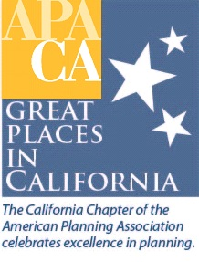
Great Places in California Program
October 2015

In May of this year, the Chapter awarded its first set of Great Places in California. The following places were selected by the jury:

- American River Parkway, Sacramento
- Balboa Park, City of San Diego
- Old Town Monrovia, Monrovia

The program, when first implemented, focused on determining the characteristics of a Great Place, followed by the process and criteria for selection. The process for awards, however, has yet to be formalized.

National APA Process
APA acknowledges Great Places with a significant press campaign, including e-blasts to the membership (via Interact) and front page announcement on the APA website. Additionally, the sponsor of each selected location has the opportunity to organize its own special event, with APA National arranging for Board representation to speak if desired. National representation is typically someone local (i.e. Region VI Representatives and/or Chapter President). APA selects one location out of the 30 awarded as the formal ‘kick-off’ event after the winners are announced at which National representation, such as the APA President and/or Executive Director, is in attendance.

The organization sends the award recipient an official certificate (parchment style paper similar to a proclamation, in a document folder). Recipients are free to frame the certificate for presentation at special events, at their own expense. For a more formal option, APA National selected a company (Franklin Bronze Plaques in Philadelphia) as the authorized vendor of plaques that mark locations honored through the Great Places in America program. Award winners can purchase a plaque for $773, with additional plaques available at a reduced price (with mounting hardware for purchase as well).

APA California Process – 2015
At the Chapter level, an e-blast to the membership was done and acknowledgement was also made available in this year’s conference program. A brief slide show presentation during a plenary session at the conference was initially envisioned, however it was recently decided that announcement during the Annual Awards event would be a better option this year. A feature article in an upcoming CalPlanner is anticipated. Award winners and sponsors were encouraged to be acknowledged at Council/Board or Supervisors meetings, Local Section Awards events and via press releases through local media outlets.
Recommendation
At this time, additional feedback and suggestions on potential policy language for the awards process is being solicited, specifically with regards to:

- Award Certificate

  - Award winners can choose to purchase a frame, or have their official certificate professionally framed, and expense the cost to the Great Places line item budget (with price cap of $50-75).

  - APA California can acquire the services of its current awards vendor to design a plaque template (using the Great Places budget), but the award winner would be responsible for purchasing an actual plaque, if desired.

- Formal Acknowledgement of Award

  - Coordinate with VP Conferences and the local CHC on a separate venue to acknowledge Great Places during the conference – separate from the Annual Awards ceremony.

  - Budget for the Chapter President (or VPs/Local Section Directors) to attend the Local Section Awards, or other special event, to present award certificate.

  - E-blast to general membership when Great Places in California jury has selected its winners.

  - Feature article to be included in CalPlanner announcing Great Places in California winners.

