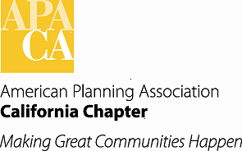

**TO:** APA California Board of Directors

**FROM:** Kimberly Brosseau, VP for Professional Development

**DATE:** June 8, 2017

**SUBJECT: Outreach to Employers – Process for Implementing in CA Chapter (Draft)**

**Goals**

* Educate employers on the benefits of their employees being AICP certified.
* Outreach to employers.
* Increase AICP memberships.
* Promote higher competency in the planning profession.

**Preliminary Work on Outreach**

* Vice President of Professional Development to work with Section PDO’s on their ideas and suggestions for outreaching within their Sections.
* Come up with ideas on how to promote in a marketing type way the importance and benefits of AICP.

**Resources Available**

* Wording in the Strategic Plan of the American Institute of Certified Planners
* Handout on National website about “Earn certification by the AICP and help your employer excel.”

**Suggestions for Implementation**

* Create an outreach letter to send to employers.
* Create a list of cities and counties, private planning firms and non-profits, and other agencies or organizations where planners work of which to send outreach letter to.
* Letter will be on behalf of the State Chapter, with President Signature.
* Review and use information in the CA Chapter Strategic Plan regarding the goals of AICP.
* Use language from National in handout relating to organizations support for employees to become AICP.

**Timeline**

Need to Develop