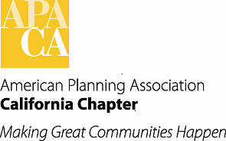 Agenda Item # _____________

TO: APA California Chapter Board

FROM: Terry Blount, AICP, Vice President of Professional Development

DATE: APA California Chapter Board Retreat, January 2015
SUBJECT: Programs Coordinator, AICP Exam Workshop Coordinator, and FAICP Coordinator
Recommended Action:

Receive and file.

Background:

Shortly after the Chapter Annual Conference at Disneyland I began working closely with the outgoing Vice President of Professional Development, Betsy McCullough, to better prepare myself for taking over from her. I have participated in the Section PDOs conference calls and other conference calls related to online certification maintenance opportunities. I also went to San Diego last November to meet with Betsy so I could have a dialogue with her about the Vice President of Professional Development position and get as much background information as possible on the duties and responsibilities of the position and on all of the activities and projects that she has been working on. What I quickly discovered is that she has set me up for success, as she has done an incredible job in the position. My goal for the near term is to basically pick up where she left off.

In addition to the Chapter staff there are three key positions that assist the Vice President of Professional Development, the Programs Coordinator, the AICP Exam Workshop Coordinator, and the FAICP Coordinator. Scott Mende has agreed to work as the Programs Coordinator and Kim Brosseau will continue on as the AICP Exam Workshop Coordinator. The position of FAICP Coordinator remains unfilled. I have done extensive outreach to try and find a suitable person for the position but have not been able to do so to date. The position was advertised through the California Planning Roundtable, Chapter email blast, and a number of contacts I obtained through conversations with various Chapter members over the past several months. I am continuing to follow up on a few leads, but if any Board member knows of anyone who might be interested please give me their name and contact information. I hope to have the position filled shortly.

