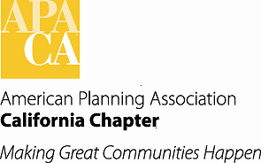

**September board meeting**

**The Sheraton Hotel, Sacramento**

**Bataglieri Room, 2nd FLOOR**

**saturday, september 23rd, 2017**

**9:00 am – 4:00 pm**

**9:00 am Call to Order / Welcome & Introductions**

**A. Approval of the Consent Items**

1. Approval of Agenda
2. Approval of Minutes (Attachment)
3. Approval of Membership Report (Attachment)
4. Approval of 2017 Financial Reports (Attachment)
5. Chapter Historian Report (Attachment)

**B. Board Member Updates**

1. President (Parkinson)
2. Policy & Legislation (Terrell) (Attachment)
3. Professional Development (Brosseau)
4. PEN Request and CPAT Update (Paternoster)

**C. Budget and Finance (Asp)**

1. Consider and Approve 2018 Draft Budget (Attachments)
2. Section Professional Booking Services (Attachment)
3. California Planning Foundation Request (Borelli) (Attachment)
4. Accounting and Financial Stability Subcommittee Update

**11:00 am D. Planners4Health Update (Miguel Angel Vazquez)**

**11:30 – 1:30 Adjourn to Student Awards Luncheon** (Luncheon is 11:45 to 1:00)

**1:30 pm Reconvene Board Meeting**

**E. Conferences (Hom)**

1. 2017 Conference Overview (Hom) (Attachment)
2. 2018 Conference Update (Brooke Peterson) (Attachment)
3. Recommendations for Future Conference Funding (Hom)(Attachments)
4. 2019 Conference Co-Chairs (Williamson) (Attachment)

**F. Section Directors’ Updates**

**G. Outgoing Board Member Recognition**

**4:00 pm Adjourn**