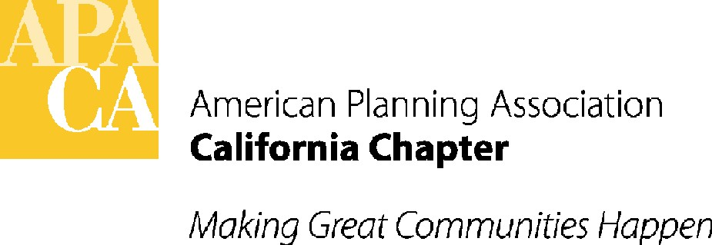

April 11, 2016

Assembly Member Levine
Room 2141
State Capitol
Sacramento, California 95814

SUBJECT: Support for AB 2087(LEvine) – Regional conservation frameworks – In Assembly Water, parks and wildlife committee – April 12th

Dear Assembly Member Levine:

The American Planning Association, California Chapter (APA California) is pleased to support your bill, AB 2087. AB 2087 would provide a new conservation planning tool to identify wildlife habitat conservation needs on a regional scale, in order to help guide infrastructure planning and development, improve the effectiveness of public expenditures for conservation, and identify potential advance mitigation solutions for large public infrastructure projects.

This measure will help implement the recently adopted State Wildlife Action Plan strategies for protecting biodiversity. The bill would also provide for faster and more cost-effective delivery of public works projects, and for effective mitigation on projects in advance of adverse effects to protect the state’s biodiversity.

If you have any questions, please contact APA California’s lobbyist, Sande George with Stefan/George Associates, 916-443-5301 or sgeorge@stefangeorge.com.

Sincerely,
John Terell
John Terell, AICP
Vice President Policy and Legislation
APA California
jcterell@aol.com

CC: The Assembly Water, Parks and Wildlife Committee, Republican Caucus, OPR, the Governor

