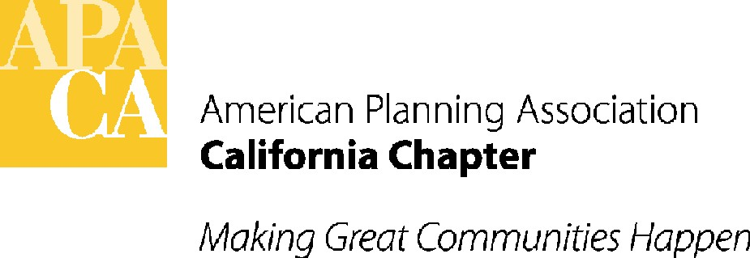

April 13, 2016

Assembly Member Gordon
Room 3013
State Capitol
Sacramento, California 95814

SUBJECT: Support for AB 2319 (Gordon) California infrastructure and economic development bank - In Local government COMMITTTEE APRIL 20th

Dear Assembly Member Gordon:

The American Planning Association, California Chapter (APA California) is pleased to support your bill, AB 2319. This bill would expand the authority of the California Infrastructure and Economic Development Bank by adding affordable housing to the types of projects to which the bank is authorized to provide financial assistance, and require the Bank to make loans to a local government for the development of affordable housing by the local government.

This bill will give local jurisdictions another much needed tool in the development of affordable housing, which is greatly needed in our communities.

If you have any questions, please contact APA California’s lobbyist, Lauren De Valencia with Stefan/George Associates, 916-443-5301 or lauren@stefangeorge.com.

Sincerely,
John Terell
John Terell, AICP
Vice President Policy and Legislation
APA California
jcterell@aol.com

cc: The Governor
OPR
Assembly Local Government Committee
Republican Caucus

