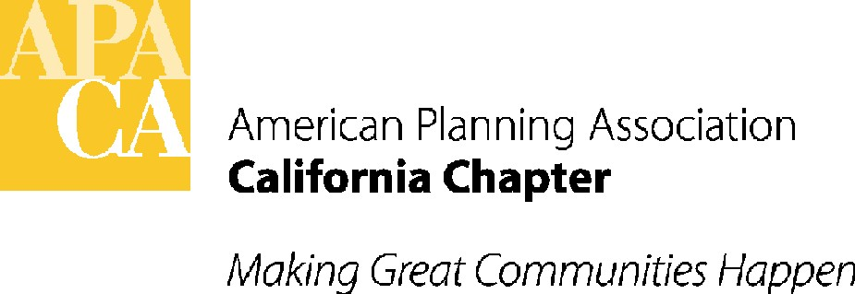

April 5, 2016

Senator Loni Hancock
Room 2082
State Capitol
Sacramento, California 95814

SUBJECT: OPPOSE – SB 1277 (HANCOCK) – STATE OVERRIDE OF CEQA LEAD AGENCY AUTHORITY - IN SENATE TRANSPORTATION COMMITTEE – TUESDAY, APRIL 12

Dear Senator Hancock:

The American Planning Association, California Chapter (APA California) must respectfully oppose SB 1277. SB 1277 would, before approving a project necessary for and directly related to the use of a specific bulk cargo terminal in the City of Oakland for the shipment of coal, require public agencies with discretionary authority over the project to prepare a supplemental EIR to consider and mitigate environmental impacts of coal shipments through the terminal.

While APA support the State’s renewable energy portfolio, we do not support the idea of special CEQA treatment of an individual project by the Legislature.

If you have any questions, please contact APA California’s lobbyist, Sande George with Stefan/George Associates, 916-443-5301 or sgeorge@stefangeorge.com.

Sincerely,
John Terell
John Terell, AICP
Vice President Policy and Legislation
APA California
jcterell@aol.com

cc: Members of the Senate Housing & Transportation Committee
Republican Caucus
The Governor
OPR

