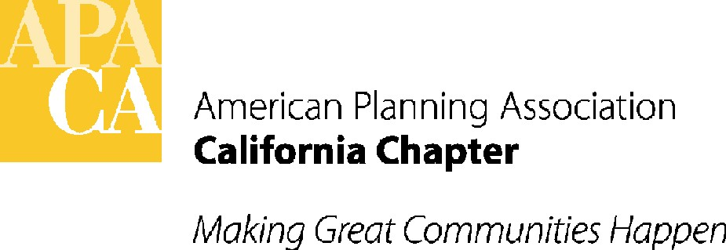

May 16, 2016

Senator Bill Monning
California State Senate
State Capitol, Room 313
Sacramento, California 95814

SUBJECT: SUPPORT for SB 313 – zoning ordinances and School Siting

Dear Senator Monning:

The American Planning Association, California Chapter (APA California) has taken a support position on your bill, SB 313, which will require school districts to notify a local jurisdiction 30 days before a vote to make a zoning ordinance inapplicable to a proposed school site.

APA California is appreciative of your efforts to increase the coordination between local jurisdictions and school districts. Upfront communication with a jurisdiction helps to ensure schools are not located in areas that don’t make since, pose health and safety issues or create sprawl.

If you have any questions, please contact APA California’s lobbyist, Lauren De Valencia with Stefan/George Associates, 916-443-5301, lauren@stefangeorge.com.

Sincerely,

John Terell
John Terell, AICP
Vice President Policy and Legislation
APA California
jcterell@aol.com

CC Members of the Assembly Education and Local Government Committee

