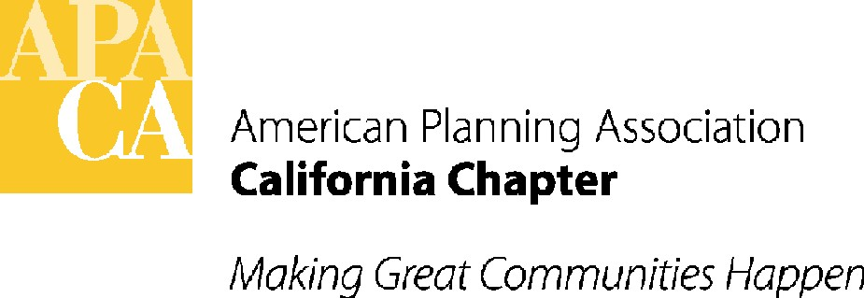

March 21, 2018

Senator Scott Wiener
State Capitol, Room 4066
Sacramento, California 95814

SUBJECT: support for sb 918 (wiener) – Homeless Youth Act of 2018
In Senate Human Services Committee – April 10th

Dear Senator Wiener:

APA California is pleased to support your bill, SB 918. SB 918 would create the Office of Homeless Youth within the Department of Housing and Community Development and would require the Office to set specific goals to prevent and end youth homelessness in California. The bill would also establish $60 million in grants from the cannabis tax and other funds to assist in the development of supportive housing and other preventative services.

APA California supports this measure and the others now moving through the Legislature that seek to develop housing and supportive services for those experiencing homelessness – equally important is preventing homelessness from the start. Tackling youth homelessness is a critical part of ending California’s larger homeless crisis and we appreciate your efforts.

If you have any questions, please contact Lauren De Valencia, Stefan/George Associates, APA California’s lobbyist, at 443-5301, lauren@stefangeorge.com.

Sincerely,
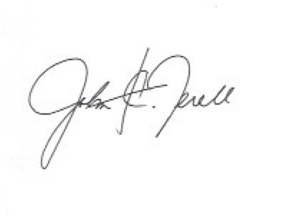
John Terell, AICP
Vice President Policy and Legislation
APA California
jcterell@aol.com

cc: Members of the Senate Human Services Committee, The Governor, OPR, Republican Caucus

