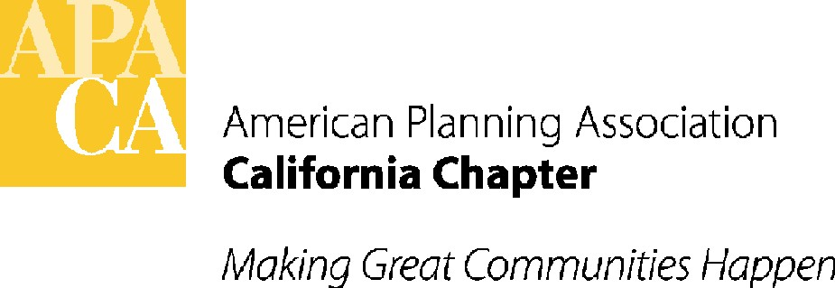

April 4, 2018

Senator Ben Allen
State Capitol - Room 5072
Sacramento, California 95814

SUBJECT: support for SB 1015 (allen) – California Climate Resiliency planning – In Senate Environmental Quality Committee – April 18th

Dear Senator Allen:

APA California is pleased to support your bill, SB 1015. SB 1015 would establish the California Climate Resiliency Program (CCRP). The CCRP would increase resiliency to climate change impacts in urban and rural communities and fund the planning and implementation of projects that reduce emissions of greenhouse gases and improve the climate change resiliency of natural systems, natural and working lands and developed areas.

APA California supports your efforts to fund programs that will help address the ever-changing climate of our communities. Over the past few years, we have seen the effects of climate change within our communities. Droughts, flooding, wildfires and mudslides are all evidence of a new normal -- we must continue to learn from these devastating disasters. APA California appreciates your efforts to fund proven projects at a regional level to promote resiliency and increase the state’s ability to mitigate and adapt to the impacts of climate change.

If you have any questions, please contact Lauren De Valencia, Stefan/George Associates, APA California’s lobbyist, at 443-5301, lauren@stefangeorge.com.
Sincerely,

John Terell, AICP
Vice President Policy and Legislation
APA California
jcterell@aol.com

cc: Members of the Senate Environmental Quality Committee, The Governor, OPR, Republican Caucus

