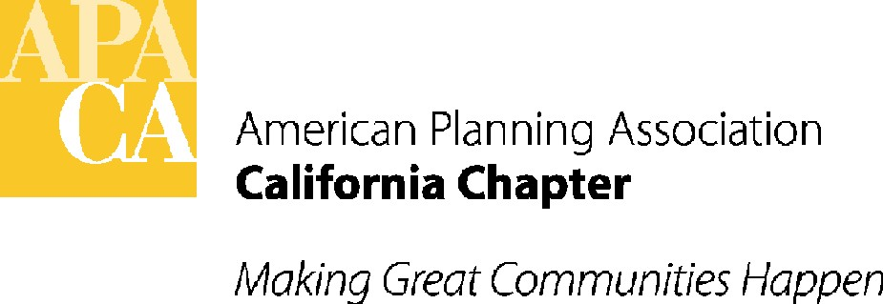

March 26, 2018

Senator Patricia Bates
State Capitol
Room 305
Sacramento, California 95814

SUBJECT: support for SB 1226 (Bates) – Permitting for existing accessory dwelling units – in Senate Transportation and Housing Committee

Dear Senator Bates:

APA California is pleased to support your bill, SB 1226. SB 1226 would allow local governments to apply the building standards in effect at the time of construction for the purpose of permitting existing unpermitted ADUs.

APA California supports strategies that will help combat the housing crisis our communities are facing. ADUs are an important source of new housing in existing parts of the community. This bill will encourage local governments to identify unpermitted ADUs in their jurisdictions and incentivize owners to bring them up to code for health and safety purposes. While we believe cities and counties under the existing California Building Code have this authority, providing explicit permission in statute will give clear direction to local governments and building officials.

If you have any questions, please contact Lauren De Valencia, Stefan/George Associates, APA California’s lobbyist, at 443-5301, lauren@stefangeorge.com.

Sincerely,
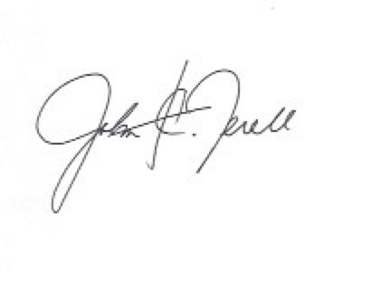
John Terell, AICP
Vice President Policy and Legislation
APA California
jcterell@aol.com

cc: Members of the Senate Transportation and Housing Committee, The Governor, OPR, Republican Caucus

