**ACCOMPLISHMENTS SINCE 2013-2014 STRATEGIC PLAN**

* CalPlanner revamp
* Student membership
* YPG commitment
* Money for historic archives
* Outstanding Conferences
* Increased CPF endowments
  + Giving out more scholarships & money
* Webinar system
* Organization Administration: updated financial policies, by-laws & conference policies, new book-keeper, “Taking Care of Business”
* Increased deposits to reserves
* Higher visibility due to STORs, etc.
* Chapter is more inclusive of/with Sections and vice-versa
* Financial stability through and after the recession
* Legislation influencers – “Heft” of program
  + Listened to
  + Results
  + Policy vs. local control
* Professional development conference(s) – benefit all
* Collaboration with/across sections
* Sections – value added to members
* Branding/Marketing consistency – value to membership
* Increased E-Blasts to members, inclusive of policy/legislation efforts
* Chapter’s influence on National APA leadership and policy
* Stronger media presence and communications
  + Media is calling APA CA
* Technical advances – website, twitter, etc.
  + Communication value to members and non-members

**THEMES AND VALUES**

**Themes**

* Communications
* Organizational Development
* Professional Development
* Policy & Legislation (Advocacy)
* Membership

**Organizational and Professional Values**

* Inclusion and Diversity
* Social and Environmental Justice
* Great Communities must be healthy communities
* Constant improvement of our planning skills
* Taking Care of Business

**Q1. IS THIS LIST COMPLETE? DO WE NEED TO ADD OR SUBTRACT ANYTHING?**

**T & V (Theme & Value)**

T – Additional Taking Care of Business – Association Management

V – Good communication to members

T – Push the policy envelope (?)

Vision vs. accomplishment (?) – balance between the two or both?

V – Acknowledge Challenges

Be honest

Guide the “solution”

T – Infrastructure

T – Viewed as “Neutral Broker”

Honest brokers

Conveners

**Vision**

**Influence**

Education/

InformEd

**Accommo-dation**

**Q2. WHAT ARE THE CHALLENGES AND OPPORTUNITIES THAT YOU SEE FOR APA CALIFORNIA AND THE PLANNING PROFESSION IN THE NEXT TWO YEARS? LONG TERM?**

|  |  |
| --- | --- |
| **Challenges** | **Opportunities** |
| * Attracting/maintaining new professions * Bad news messaging * Influencing local decisions * Alternative facts – cut through the truth * Getting our message through the clutter * Not treated as professional experts * Prevent short-term action from leading to long-term guard against * Diversity/inclusion – does not reflect the communities we work in * Non-profit planners * Diversity – need to address structurally and need money to include these new members | * Post-Brown influence – RDAs * New professionals * “Big Tent” Planning * Technology-changing: engage and leverage * Post-fire legislation * Resiliency * “Thinking it Through” * Keep building chapter & section relationships: use our organization structure * More advocacy – use our influence to influence * Personal connection- individuals need to make the invitation for members to participate (invite people in)) * Mentorships * Awards – use this event to sell results and outcomes * Elections – bridge the gap * Reach out to other professions - i.e., happy hours * PAB – Planning Accreditation Boards: professional participation, inform reviewers of staff participation or non-participation |

**Q3. WHY ARE THESE THEMES AND VALUES IMPORTANT TO YOU AS A MEMBER OF THE APA CALIFORNIA BOARD?**

Individuals filled out sticky notes. Their responses are below.

**CORE VALUES**

* ***Communications: creating bridges with organizations who work on issues that are common***
* ***Because these themes and values are empowering***
* To make sure that everyone has a voice in planning for the future
* ***Because they are challenging and achievable***
* ***APA looking to future to respond to needs both internally (planners) and externally (communities)***
* Because they are thoughtful
* So every member of our community feels welcome
* Because these themes and values are inclusive
* Inform/educate/empower planners to be the best they can
* These themes and value are “raison d’etre”
* It promotes informed and educated discussion and decision-making
* Helps decision-makers make better decisions to improve the quality of life
* ***Ensures sustainability of the profession***
* Identifying audiences
* Finding consensus
* Guide for future leadership
* ***It validates/confirms that our goals are generally shared***

**GUIDE FOR FUTURE ACTION**

* ***Turn vision into concrete policy***
* ***To leave the planning profession better than we found it***
* Because we need to focus on the future
* To make sure planners are successful in their roles
* ***Adapt to changing political climate (counteract negative anti-planning)***
* ***Being a resource: not to have all the answers but connections to help find them***
* To create positive change in my community
* Increase visibility of planning and planners
* These values and themes point toward actions we can take as a Chapter Board; we can be result-oriented
* If APA (and other orgs) do not address continuous growth question, others will through ballot initiative process – APA is irrelevant?
* ***Clear priorities allow us to be more effective***
* Ever-so critical to include marginalized and under-represented groups in our profession and communities
* We need to clarify values/themes: are we a membership organization or advocacy?
* There needs to be an extra effort to embrace our diverse membership
* To support and influence the planning community to be change agents with communities
* Empower young planners to see the path of leadership
* ***No other profession accepts accountability for the future. We lead the professio***n.
* ***It encourages inclusivity and collaboration in planning for tomorrow***

**ORGANIZATION**

* Continue to grow the organization
* Making sure the organization is stable
* To keep the organization relevant
* Professional development
  + membership organization
  + what benefit do we provide?
  + as experts & leaders we have a responsibility to help our members grow personally and professionally
* I care about the success of the organization because I am personally invested
* ***Increase diversity in the organization***
* Help us to sustain and improve our organization
* ***Understanding other Board members***
* Important to build leadership capacity in the profession and organization with students and new professionals
* Stable board structure (financial health, by-laws, communications, etc.) in order to be THE resource
* Organizational development: outreach to planners to create more diverse board
* ***Be effective as an organization in influencing policy makers***

**PERSONAL COMMITMENT**

* Successful APA CA helps me be a more successful planner
* I want to promote good planning at the State and local level
* ***In-line with my personal and professional passion to give back to the profession***
* People want to live in great communities
* ***Themes can be aligned with what I enjoy***
* ***Shape better communities (which is reason I entered the profession)***
* ***Because I believe in the power of this organization to guide change in the profession and our communities***
* ***Themes prioritize what I do***
* These values resonate with my personal values
* Themes and values are key elements of the story we need to be able to tell about ourselves, collectively and individually
* ***Values focus my efforts***
* To be able to create and build great communities to live, play, and work
* ***Values guide how I act/behave***
* ***At our core, we are a holistic profession; these themes and values define our holistic perspective and give it meaning***
* They establish a cohesive goal for the entire organization
* They provide a framework to build upon
* They define our personal role as a planner and APA member
* ***To always improve myself in my profession***
* Because I believe that a community supported by good planning supports better lives for people!

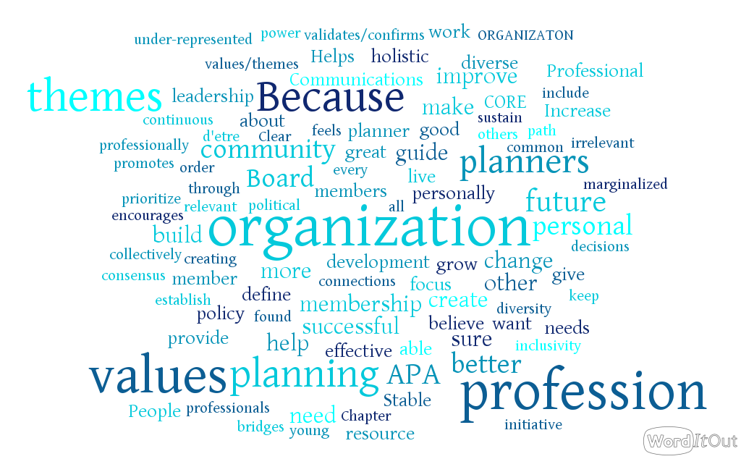

**Q4: WHAT ARE THE KEY OUTCOMES YOU WOULD LIKE TO SEE IN RELATION TO THESE THEMES BOTH IN THE NEXT TWO YEARS AND IN THE FUTURE?**

**Summary of Group Reports (5 Groups)**

| **Outcome** | **Short-Term** | **Long-Term** |
| --- | --- | --- |
| **ORGANIZATION** | | |
| **Network** with allied group (state and local, including non-profits, league of cities, ULI, health   * Advocacy * Legislative priorities * Local advocacy – look for missing pieces | X | X |
| **Student** membership   * How to retain? * What does APA offer (what are the carrots in our toolbox)? * Need examples from leaders in their work place/organizations * Adopt a university | X | X |
| **Communications**   * Internal and external |  |  |
| Increase **membership**   * Identify growth percentage (%) we want * Support to section membership directors |  |  |
| Does **current structure** support our goals?   * Does funding match the goals? |  |  |
| Invest in **leadership** development   * i.e., speak at high schools |  |  |
| **Diversity**   * in chapter & section leadership * needs to reflect the student population | X |  |
| **Sections & State**   * Continued improvement of relationships | X | X |
| Webinars – new profit center, less financial focus on state conference for money   * i.e., planning commissioners | X | X |
| Revisit section conference rotation system   * including impact of national conferences on state conferences |  | X |

|  |  |  |
| --- | --- | --- |
| **Outcome** | **Short-Term** | **Long-Term** |
| **GUIDE FOR FUTURE ACTION** | | |
| **Legislative** Platform   * Streamline it – 1 to 2 pages * Council of legislative representatives * Advocacy training: 1) chapter – section: leg review teams, influence local policy, 2) every section has leg representative * Need for National – Chapter – Section connection * Connect with local elected officials/engage and invite them to local events * Allied group relationships – state & sections * APA at League conference – let’s to the elected * Broadcast our role in legislation and other successes   + Grassroots planning network | X  X | X |
| **Professional development**   * “Missing Middle” planners group |  |  |
| APA **Thought Leaders/Influence targeted connections**   * Academics * Content-oriented events or webinars * Sacramento Legislative Conference (Julia, Kurt C) |  |  |
| APA CA 75th Anniversary in 2023 – Let’s Tell Our Story |  |  |
| Policy: CA to lead by example to influence National APA |  |  |
| Public Health: network with allied groups | X |  |
| Focus on issues where we can **build our profile** |  |  |

Group Notes

1. Communications
   1. Modernization ***LT***
   2. Consistency ***Ongoing***
   3. Tailor to various audiences ***Ongoing***
   4. Link to advocacy through events/awards
   5. Engage local officials through communications
2. Organization Development
   1. Increase partnerships with allied groups at the State level; build upon National APA efforts
   2. Increase partnerships with League conferences to increase APA presence
   3. Formalize/be strategic about partnerships and better define them
   4. Increase/support additional local engagement opportunities to support sections
3. Professional Development
   1. Develop mid-career opportunities and programs
   2. Work with National APA?
   3. Pilot mid-career place/niche/home that has value
   4. PEN/CPR linkages?
4. Policy and Legislation (Advocacy
   1. Invite more elected officials to events and awards
   2. Develop more formal process for participating on Leg Review Teams
   3. Link to Planners Action Network (PAN)/capitalize on National resources for policy
5. Membership
   1. Increase membership
   2. Set target
   3. Develop membership strategy and work with sections to implement
   4. Work to retain new and student members
   5. Link to YPG for retention program

Group Notes

1. Legislative focus
   1. Core hub
   2. Streamline
2. CPR modules for middle management
3. LA Elementary Magnet School for urban planning
4. Strengthen network
   1. Allied organizations
   2. Non-profits
   3. Public health
5. Membership
   1. Retention of students and YPG
   2. Growth diversity
   3. Set target numbers

Group Notes

1. Inclusion
   1. Non-profits
   2. Academics
2. Legislative Platform
   1. Influence
   2. Council of legislative representatives in all sections ***LT***
      1. Prepare a toolbox for training
   3. 2-year streamlined platform ***ST***
   4. Policy and leg representatives – expect them to be on Leg Review Teams
   5. Advocacy at the Section level to help inform local elected ***LT***
      1. Training
      2. Knowledge
   6. Policy & Legislation Call with all Sections

Group Notes

1. I'd like us to become thought leaders-we don't have to be the experts. We can bring the experts in to help form the thoughts
2. Need to build relationships with other organizations because it will help us achieve goals and values such as the league, cascading and county planners, public health profession, AARP
3. Need to prepare sections to work with advocacy groups
4. Look for opportunities to work together with advocacy organizations perhaps coupons or events  
   I would like to be more SPUR-like connecting to electeds
5. We don't need to ask any more what the issues are-we need to say these are the issues and set up the ability to discuss
6. Need to rethink the structure of the organization. Maybe instead of electing, maybe we should think about appointing. Increasing leadership diversity and a basic level of services.
7. Smaller scale sections have problems getting people, together and limited access to academia.
8. How do we make the investment of time valuable? How is it relevant to the next generation?
9. Need to think how we communicate in snippets, younger generation want quick information
10. Electronic archives and strong web presence is critical
11. Think about how members want to spend their time-statewide compared to local issues
12. How to share communications from sections and state chapter
13. Are there certain services that we want to bring in and pay for to do bookkeeping for example
14. Can we establish a chapter-level sponsors? Something to think about.
15. How can we tap into Planetizen, for example?
16. Why not use universities to do AICP prep? Or rely on Planetizen
17. Do we need to think about growing membership but focus on membership retention
18. I want to grow the thinking of who is a planner? There are many people who have jobs that impact planning who are not defined as planners. They need to be members. For example, land use attorneys, planning commission members, housing, OPR staff, OES staff
19. Leadership development is key. Investing in our leadership for planners in APA and in the profession-tailored to California.
20. (National will be rolling out Plan to Lead) this will be an opportunity
21. Take advantage of PEN CPAC is a great opportunity
22. National ambassador program is another opportunity to grow.
23. Work with academics to put together webinars
24. Association of Collegiate Planning Schools is another opportunity to engage academics.

Group Notes

1. **Great Communities, Justice and Social Equity, Policy**: Make Cal APA relevant to impact the National policy discussion. Lead by example. ***Short term and long term.***
2. **Organizational Inclusion and Diversity**: More people of color in Leadership and makeup of profession. Put structure in place to make that attractive. Outreach to nonprofits. ***ST*** (See No. 6)
3. **Taking Care of Business:** symbiosis between chapter and sections. Continue strengthening these relationships. ***ST LT***
4. **Inclusion and Diversity:** Successful integration of students and new professionals, maintain those members as they grow and develop. Establish metrics to measure success in two years. ***Metrics are ST, measurement is LT***
5. **Great and Healthy Communities**: Permanent strategic alliance with the public health profession and identify other groups with which to build these alliances. ST
6. **Diversity and Inclusion:** Leadership comes closer to reflecting the diversity of the student population. Note the arrival of an LAUSD magnet school focusing on urban planning. (Relates to No. 2) ***ST Goals, LT implement. Monitor trends over time.***
7. **Policy; Vision v. Accommodation:** Continue APA California’s focus on issues where we can continue to build our profile — infrastructure, for example. Growth and community capacity, community services infrastructure (schools, libraries, parks). Communities cannot keep up with the capacity needed to handle that growth. APA should be at the forefront rather than background of that conversation. ***LT***
8. **Policy:** continue broadcasting our role in legislation, reporting on successes, getting involved. Your voice can help shape legislation. Demonstrate the direct connection, direct benefit of getting involved. The outcome should be to build a grassroots planning advocate network. ***LT***
9. **Take care of business; skill development:** Webinars — successful generation of a profit over next two years for the webinar program to reduce reliance on the annual conference e as a major generator of revenue. Identify other potential sources of revenue: sponsorship programs (consistency and overlap issues). Expand conference participation through distance learning, taking conference events and broadcasting them. Pilot the keynote speaker event. ***ST and LT***. At end of two years we should have a robust program of statewide section activities, such that folks know we are all part of the same organization. Ex: PC training. ***ST and ongoing***
10. **Taking Care of Business:** Re-evaluate our Siting Practices for Conferences to determine whether the rotation system currently in place continues to meet our members’ needs. LT
11. **Taking Care of Business**: State v National Conferences: have a game plan in place to reflect the fact that there will be two national conferences in California in the next 5 years, in order to address potential impacts on our state conference and our ability to support both a State and National Conference in a single year. ***ST***

APA CAlifornia Strategic plan

2018-2019

# 2-Year Action Plan

**Assignment-** The leads for each team below shall convene the team as needed to prepare a draft action plan to report back to the Chapter President / President-Elect by March 3, 2018.

**NETWORKS** – strengthening and expanding networks with specific emphasis on: (1) allied organizations, (2) non-profits, and (3) building a permanent and substantive alliance with public health professionals.

***Team Leads: Marc, Nick C.***

***Additional members: Stephen, Julia***

**MEMBERSHIP-** Sustainable Chapter membership with the following emphasis:

1. Student/New Member retention
2. Targeted growth:
   1. Academics
   2. Planning related professionals
   3. Diversity
   4. Missing middle professionals
3. Develop a specific measurable goal (i.e. number of members)

***Team Leads: Mary, Juan***

***Additional members: Julia, Miroo, Chris, Ashley, CPR, Sande***

**DIVERSITY-** deepen the diversity of our membership and Chapter and Section leadership

***Team Leads: Mary, Miroo***

***Additional members: John H.***

**CHAPTER/SECTION RELATIONSHIPS**

***Team Leads: Rachel, Sharon***

***Additional members: Ashley, Nick C., John H.***

**POLICY/LEGISLATION** – Specifically considering the following: (1) Council of legislative representatives, (2) Chapter/Section advocacy training, (3) stronger National/Chapter/Section connection, improved advocacy at the local level, (4) stronger allied group relationships, (5) Cal APA sponsored session(s) at Cal League of Cities conference, and (6) a grassroots planning advocacy network.

***Team Leads: John, Nick M***

***Additional members: CPR, John H, Stephen***

**INFLUENCE NATIONAL APA: POLICY AND LEADERSHIP**

***Team Leads: Pete, Kristen***

***Additional members: Marissa, Kurt***

**DIVERSIFY CHAPTER REVENUE SOURCES** – Reduce reliance on annual conference income

***Team Leads: Sung, Hanson***

***Additional members: none***

**EVALUATE ORGANIZATIONAL STRUCTURE**

***Team Lead: Julia***

***Additional members: Pete, Jeff, Collette***