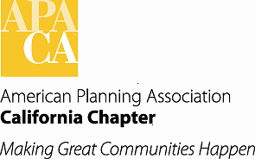

**June board meeting**

**APA Conference Line**

**Friday, June 15, 2018**

**9:00 am – 1:00 pm**

**Conference Line: (866) 499-7054**

**Passcode: 2991253365**

**9:00 am Call to Order / Welcome & Introductions**

**9:05 am A. Approval of the Consent Items**

1. Approval of Agenda
2. Approval of Minutes (Attachment)
3. Approval of Membership Report (Attachment)

**9:15 am B. Board Member Updates**

**10:45 am C. Action Items**

1. Fees for Webinars and Session Recordings (Brosseau) (Attachments)
2. Strategic Plan Update (Lave Johnston) (Attachment)
3. Section Commission and Board Representative (Haase) (Attachment)
4. New Chapter Financials Proposal (Kwon) (Attachment)

**1:00 pm Adjourn**