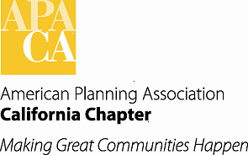

**TO: APA California Board of Directors**

**FROM: Sung H. Kwon, MCRP MBA AICP**

**Vice President of Administration**

**DATE: September 26, 2018**

**SUBJECT: Request to amend to Award Policies**

During the review of award nominations, one of our jurors (Tricia Stevens) requested that the Transportation Planning Award require First Place at the local section to be eligible for State nomination. Currently there are a number awards that require First Place at the local section. The Transportation Planning Award is not currently amoung that list.

Ms. Stevens felt that there were too many nominations for this award category. The nominations varied in quality and there were multiple nominations from various sections.

This request is simply to change the Transportation Planning Award description to require First Place at a Local Section. See Underlined Italics for added language:

6) Transportation Planning Award

*NOTE: Requires first place win at the Local Section level (no ties) for the same year.*

This award honors efforts to increase transportation choices for all populations, reducing dependence on private automobiles and helping to ease congestion and reducing climate change impacts.

Examples: Transportation studies; complete streets plans or projects, plans for pedestrian, streets, highways, aviation, parking, maritime, transit or rail; development and expansion of transportation systems; development and expansion of trail systems.

The Award Policy Language does not need to change. See current award policy language below:

***XII. SECTION AWARDS PROGRAMS***

***A. SECTION AWARDS PROCESS***

*There are some award categories which only first place winners of Section Awards Programs are eligible for nomination for State APA Awards [see IV. Award Categories above for those categories which require first place win at the Local Section level (no ties) for the same year.]. Such award entries must be submitted to the Section where the project, plan or work occurred first prior to being submitted to the State for consideration. Sections are strongly encouraged to support and promote their local Awards Programs.*