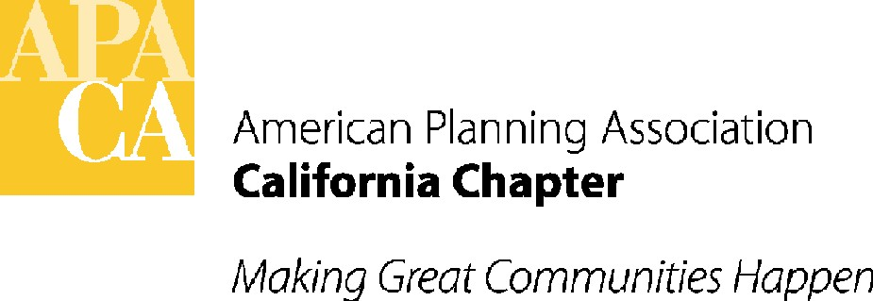

TO: APA CALIFORNIA BOARD

FROM: SANDE GEORGE, EXECUTIVE DIRECTOR

DATE: OCTOBER 1, 2018

SUBJECT: APPROVAL OF 2019 BUDGET

RECOMMENDED ACTION: Approve the 2019 Chapter Budget.

BACKGROUND: Attached is the Draft 2019 Budget for the Chapter. The Executive Board has already reviewed and approved the draft. The final budget must be approved by the full voting Board. The draft budget is based on estimated yearly income and expenses extrapolated from the Year-to-Date Actual amounts in the July 2018 Mid-Year P&L. After approval by the full voting Board, the approved final 2019 budget is still subject to change based on the final Year-to-Date Actual amounts determined after the end of 2018. Any amendments/adjustments to the final 2019 budget can be made at the January 2019 retreat.

EXPLANTION OF DRAFT 2019 BUDGET: Changes for 2019 from the 2018 budget are highlighted with notes in the “Changes from 2018” column in the draft 2019 budget and on the bottom of the draft budget. These notes explain the reason for the changes, which will be discussed at the Board meeting. Note that as estimated, this 2019 Draft Budget shows a positive $27,128 Net Income for the year. Some of the notable changes from 2018 to 2019 include:
- Dues income is projected to increase substantially in 2019 due to growing membership and a revised Chapter dues structure. (LI 4115 and 4120)
- Webcast income is projected to increase due to increased charges. (LI 4410)
- Association management fees to Stefan/George are proposed to increase by 10%, the first increase in several years. (LI 5105)
- $5,000 is budgeted for a Chapter reception at the NPC in San Francisco. (LI 5215)
- $2,000 is budgeted for the VP Professional Development to attend the NPC. (LI 5405)
- $2,000 is budgeted for website redesign with National web portal. (LI 5545)
- $10,000 is included for a comprehensive review and/or updates to the Chapter’s finances and financial reports by accountant and bookkeeper. (LI 5620)

ACTION: Approve the 2019 Chapter Budget.

