**Tijuana Walking Tour**

**2018 APA California Conference**

October 10, 2018

**Wednesday, October 10, 2018**

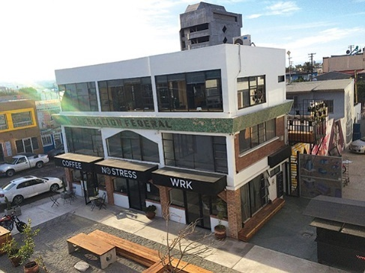

**Estación Federal**

The original plan for Estación Federal was to house border customs employees at this structure; the plan was abandoned in the 1950s. In 2016 the structure was converted to include mixed-use features including offices, retail shops, and housing. Estación Federal is one of the first modern developments in the traditional tourist area known as Centro Histórico.

**Bus Rapid Transit (BRT)**

The BRT began operations between 2016 and 2017. The city’s existing local feeder routes connect the 23-mile route, La Ruta Tronca or BRT. Point-to-point the route takes just under an hour to complete. This rapid service connects Tijuana’s main businesses, streets, and restaurants along the Avenida Revolución, Zona Río, Via Rápida, and highways near the Tijuana River channel.

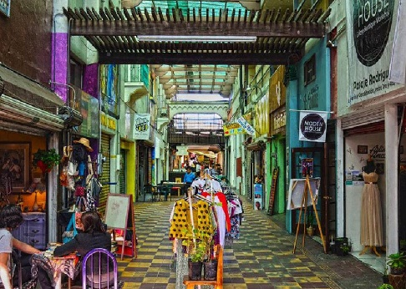The federal government, city, and private industry are sharing costs on new infrastructure to support the system. The infrastructure includes 45 stations (offering free wi-fi) with two major terminals, a bridge connecting the Tijuana border to the Downtown Terminal, and eight new pedestrian bridges. To ride, the fare cost is about 14 pesos (less than a dollar) and payment is done through a Smart Card or coins. The frequency is around 15- to 30-minutes all day.

**Pasajes**

The city has taken itself back and rejuvenated decaying pasajes, or passages, of the city with art galleries, bookstores, cafes, and local entrepreneurs selling crafts and goods. A prime example is the Pasaje Rodriguez located in the center of Avenida Revolución, its colorful buildings, tiles, and roof create a unique place for people to gather and create pride in the city once again.

**Esquina Sara**

The Esquina Sara building, for 33 years, stood as a high-end retail store. Less than five years ago, the property was acquired by the Cosmopolitan Group and was most recently transformed into a three-floor multi-use development for commercial, 33 offices, coworking space, and a Skydeck with multiple food spots for vendors. The developer’s concept for this space was to help strengthen and revitalize the Downtown area, while paying homage to the building’s historic presence. Esquina Sera provides low-cost coworking spaces to businesses (via daily or monthly renting fees) with access to amenities such as, furnished rooms, private offices, coffee area, large meeting room, projection and copying area, reception, terrace, and safety elements during the night along with 24-hour security.

**Distrito Revolución**

Distrito Revolución is the first multifamily condominium in Tijuana. A few features include, 66 condos, BBQs, underground parking, and reading areas all within 16 floors and it is on the most famous street of Tijuana, the Avenida Revolución.

**Wednesday, October 10, 2018**

**Tijuana Walking Tour**

**2018 APA California Conference**

October 10, 2018

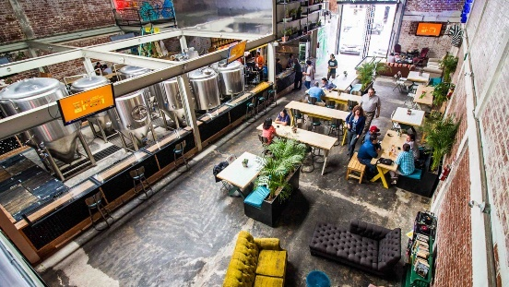**Telefónica Gastro Park**

Telefónico Gastro Park is a food truck paradise filled with gourmet, authentic Mexican food, and hip seating areas. When the park originally opened in 2014 on Boulevard Aguacaliente, they experienced rapid growth and needed more space for food vendors. To expand, Telefónico moved in 2017 to Avenida Ocampo into a two-story venue with a large outdoor patio and a bigger parking lot. Telefónico’s directors designed the new spot to focus on the in-house brewery called, Lirica.

**Mercado Hidalgo**

The Mercado Hidalgo has been open for over 60 years. It is a fresh, local, open-air food market that tourists and locals can enjoy shopping and eating. The public can watch events such as, Día De Los Muertos, where traditional dancing and rituals are performed. The building was originally designed to serve wholesale produce at the center (where the parking lot is) and provide easy transportation access with the four entrances where both automobiles and pedestrians can enter. The hours of operation are Monday-Saturday from 6am-6pm and Sunday from 6am-4:30pm.

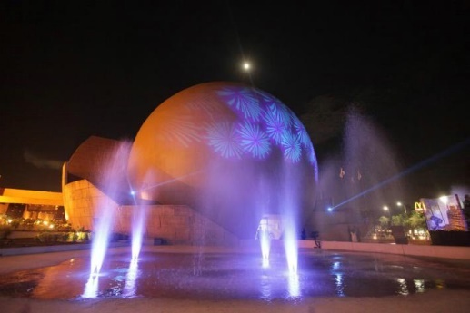 **Tijuana Cultural Center (CECUT)**

CECUT is the cultural center of Mexico, founded in 1982. It is the institution that concentrates the widest and most diverse cultural offerings of the Northwest region, and does so by offering various artistic performances, programs, and exhibits in a contemporary or traditional manner. CECUT has entertainment for all ages such as an aquarium, botanical garden, historical art, and a library. Another well-known structure is the Cinemax IMAX theatre, established in 1982, and famous for the architectural dome shape.

**City Hall or Palacio Municipal**

Tijuana City Hall is now called, Palacio Municipal and is in the new Zona Urbana Río District. The building consists of three floors, including a large open space in the center. Events are held both in-doors and outdoors. On the first level there is the Mayor’s office, a cafeteria, civil registration, social management of the presidency, technology management of computerization, management of expenses information center, and restrooms. On the second level there are the councilmembers’ office, court of justice administration (or chambers), secretary of public education, urban infrastructure management, development of social municipal, advisors of councilmembers, and more. The third level are the offices for social communication, Presidency, economics, development of urban and ecology, training and audiovisual rooms, management of alcohol beverages, religious affairs and more. Transportation options are readily accessible for the public and employees to either take the bus or park in the underground garage.



**New City Residencial**

New City Residencial complex includes condominium buildings and the highest tower in the city with a total of 27-floors. New City serves as a housing option for both Mexico and San Diego workers. With the relatively short transit commute to Downtown, San Diego, living in Tijuana is often preferred for Mexico’s young professionals and college graduates who also work in San Diego.

**Wednesday, October 10, 2018**

**Tijuana Walking Tour**

**2018 APA California Conference**

October 10, 2018

**U.S. Border POE**

**I**

**A**

**M**

**E**

**K**

**G**

**H**

**L**

**J**

**F**

**F**

**D**

**C**

**B**

**Pueblo Amigo**

**United States**

**Sara Esquina**

**Estación SITT "Calle tercera"**

**Mexico**



A screenshot of a computer

Description generated with very high confidence

**CECUT**

**Mercado Hidalgo**

**Telefónica Gastro Park**

**Palacio Municipal**

**New City Residential**

**Distrito Revolución**

**Pasaje Rodriguez**

**U.S. Border POE**

**Estación Federal**

