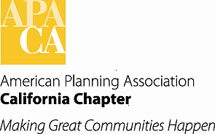

**june board meeting**

**Saturday, June 15th, 2019**

**10:30 am – 3:30 pm**

**Mogavero ARCHITECTS**

**1331 T Street**

**Sacramento, CA 95811**

**10:30 am Call to Order / Welcome & Introductions**

**10:45 am A. Approval of the Consent Items**

**1. Approval of Agenda**

**2. Approval of Minutes** (Attachment)

**3.** **Approval of Membership Report** (Attachment)

**4. Legislative Update** (Attachment)

**5. Financial Reports** (Attachment)

**11:00 am B. Action Items**

1. **Elections Policies and Procedures (Parkinson)**  (Attachments)
2. **Chapter and National Landmark Awards (Mintier)**
3. **2020 Conference Theme (Hom) (Attachment)**

**C. Discussion Items**

**11:30 am 1. CPF Raffle and Auction (Borrelli)**

**11:45 am 2. Strategic Plan Committee Updates (All)** (Attachment)

**12:30 pm WORKING LUNCH**

**12:45 pm 4. Update on New Programs Staff (Lave Johnston)**

**1:15 pm 5. Chapter Communications (Yeber)**

**3:00 am D. September Board Meeting and Conference Update**

1. **Board Meeting Logistics (Lave Johnston)**
2. **2019 Conference Update (Hom)**
3. **Ad Hoc Committee to Discuss Future Conference Planning (Hom)**

**3:30 pm Adjourn**