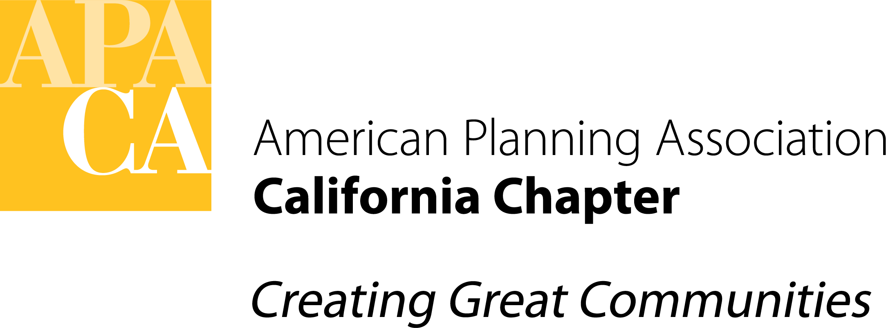

DATE: January 15, 2021

TO: APA California Chapter Board

FROM: Ashley Atkinson, President

SUBJECT: Board Agenda Development Policy

Background: To date, an informal practice has been in place for developing Board meeting agendas and requesting items for inclusion. This vote would formalize that practice, as well as submission deadlines, as official Board policy. If confirmed, deadlines will be added to the Board’s internal calendar for convenience.

Policy for Board Agenda Development

- 45 Days in Advance (Approximate): The Executive Director will consult with the President about items to be included in the initial draft agenda. The President may ask specific Board members to prepare items as needed.
- 30 Days in Advance: The initial draft agenda will be circulated to the Board by the Executive Director. This message will include a request for additional agenda items and a reminder of deadlines.
- 21 Days in Advance: Deadline to submit requests for additional agenda items to the President and Executive Director. Requests should be submitted via this Google Form. If discussion or clarification of the request is needed, the Board member(s) and President will confer.
- 10 Days in Advance: Board members responsible for agenda items will submit memos/attachments to the President and Executive Director via email. If discussion of the memo or attachments are needed, the Board member(s) and President will confer.
- 7 Days in Advance: The Executive Director will circulate a final agenda including attachments. Board members will review the agenda and attachments prior to the meeting to facilitate productive discussion.

Policy Regarding Memos & Attachments

Action & Consent Items: All action and consent items are required to have a written action memorandum providing background on the issue and clearly describing the action the Board is asked to take or consent to. Any additional attachments necessary for the Board to understand the requested action should accompany the memo.

Discussion Items: Discussion items are not required to have written memos; however, reports or other background materials are recommended to facilitate productive discussion. Board members should indicate whether attachments will be provided when requesting discussion items for inclusion in the agenda.

