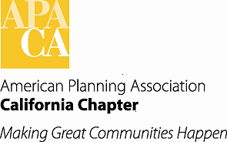

**DATE: January 7, 2021**

**TO: APA California Board of Directors**

**FROM: Steve Preston, FAICP, Chapter Historian – South**

**Larry Mintier, FAICP, Chapter Historian - North**

**SUBJECT: REVISED ADMINISTRATIVE POLICY – SUBMISSION AND RETENTION OF RECORDS FOR THE APA CALIFORNIA ARCHIVES**

­

The Chapter Board adopted an Administrative Policy for “Retention and Preparation of Chapter and Affiliated Organization Records for the APA California Archives” on March 18, 2016. While this policy provides extensive guidance for the collection and archiving of the records of the Chapter and its affiliated organizations, the Policy provides little guidance concerning the collection and archiving of other documents that address the broader history of planning practice in California (e.g., local general plans, regional plans, reports published on planning topics by NGOs.) As planning practitioners retire, downsize libraries, and die, the practitioners, their colleagues, or their families often donate their libraries to the Chapter Historians or university faculty members. Similarly, planning agencies and consulting firms periodically purge their libraries and may look for an organization to donate their documents to. This revised Administrative Policy incorporates and expands the Policy adopted by the Chapter Board in 2016 to include guidance for the collection and archiving of private donations to the Chapter Archives at Cal State Northridge. It also includes a pair of overarching objectives to guide the administration of the APA California Chapter Archives and updated guidance on submission of material in digital format.

**Recommendation**

The Chapter Historians recommends that after review the Chapter Board adopts the Revised Administrative Policy for Submission and Retention of Records for the APA California Archives (see attached Exhibit).