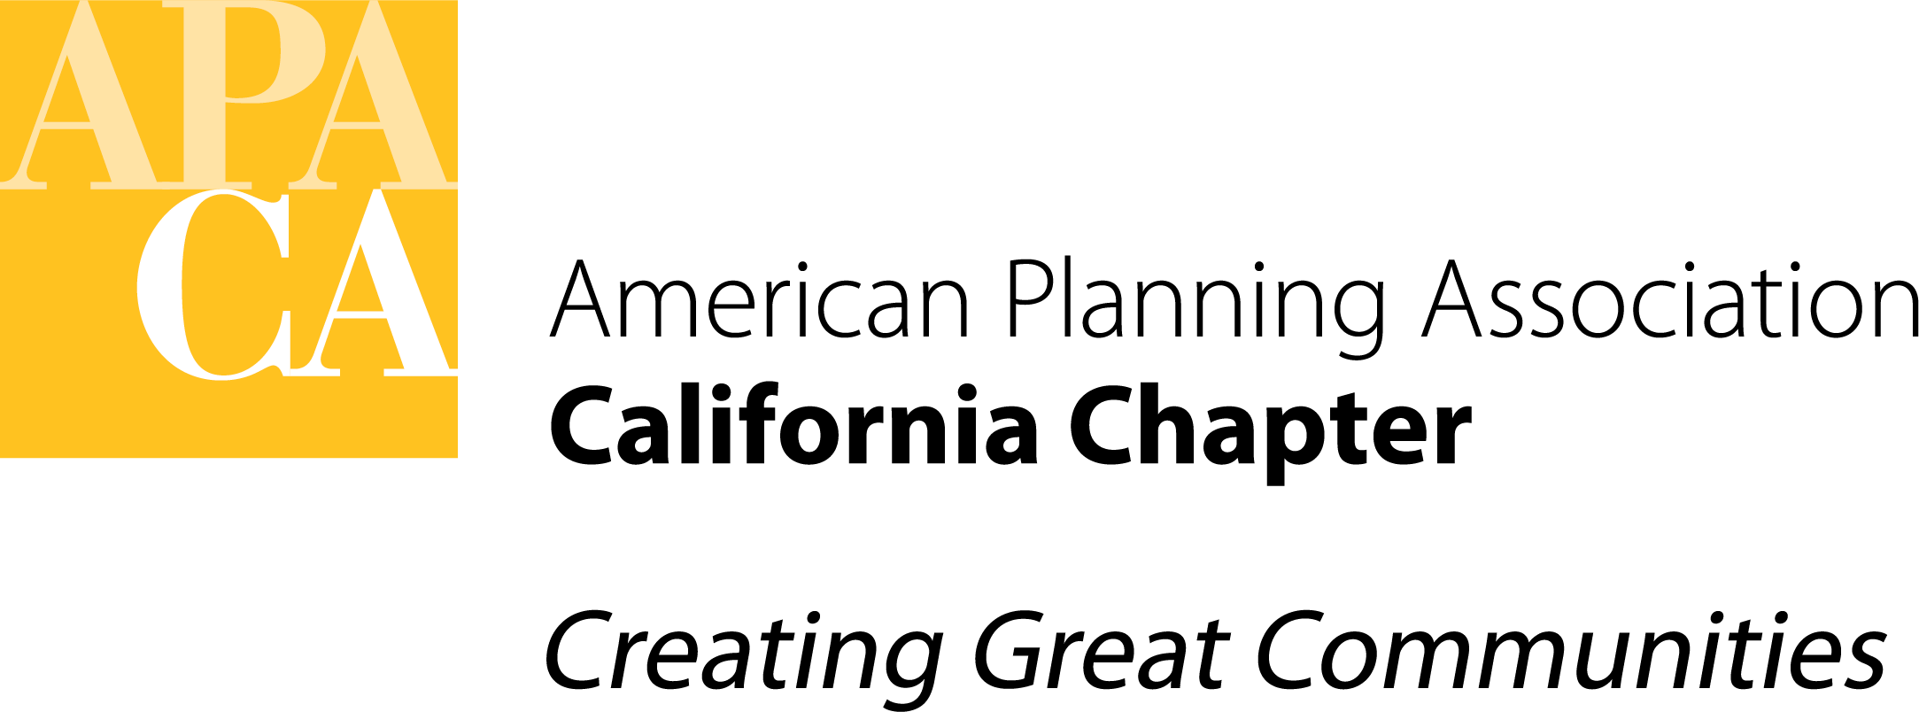

TO: APA California Chapter Board

FROM: Eric Phillips, Vice President for Policy and Legislation

DATE: January 22, 2021

SUBJECT: Plan California Legislative Platform for 2021-2022 Session

Recommended Action:

Move to approve the draft language changes to the Plan California Legislative Platform and direct the Vice President for Policy and Legislation to prepare a final version to be posted on the Chapter website and shared more broadly with members.

Background:

As discussed at our June 2020 Boar Meeting, I have prepared a draft of “Plan California,” which will be the Chapter’s official legislative platform for the 2021-2022 Legislative Session after it is reviewed and approved by the Board (the “Platform,” attached). The Platform outlines our professional views on priority issues, and it informs the positions we take with respect to specific legislative proposals and for advocacy positions taken by the Chapter.

The Chapter adopts a new Platform prior to the start of each two-year Legislative Session. The proposed draft Platform follows the structure and contents of the 2019-2020 Platform, with the exception of several key changes noted below.

The previous topics of “Housing” and “Density” are proposed to be combined, since there was significant overlap among the Planning Principles identified in each topic. I also have proposed elevating the “Inclusion and Social Justice” topic by including it earlier in the Platform, and I have added several new Planning Principles based on National APA’s Equity Platform to add more detail to our potential policy positions.

There are a number of specific language changes and additions proposed to reflect new laws that were adopted in the last session and bills that we anticipate will be (or have already been) introduced during the current two-year session. To facilitate your review, a redline showing each proposed change from the 2019-2020 Platform is attached.

Fiscal Impact:

No cost to Chapter beyond Board and staff time.

Attachments:

Draft Plan California: Legislative Platform 2021-2022 Legislative Session
Redline of changes from 2019-2020 Legislative Platform

