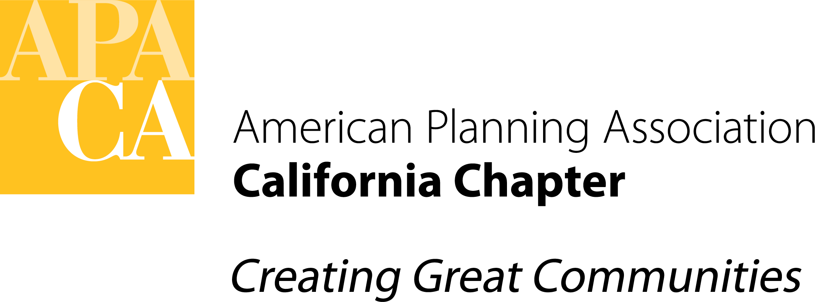

DATE: December 9, 2021

TO: APA California Chapter Board

FROM: Ashley Atkinson, President
Vice Presidents of Administration, Conferences, Marketing & Membership, Policy & Legislation, and Professional Development

SUBJECT: Appointment of Chapter Advisors for 2022

The Board is asked to consent to the appointment or re-appointment of the individuals below to Chapter Advisor positions for 2022. These appointments are being presented by the President in consultation with the sitting and elected Vice Presidents to whom they report. An open call for applications was held in the month of November 2021, resulting in seven new candidates for positions in which re-appointments were not sought.

The duties of these positions vary according to the bylaws, but all will serve a one-year term. The Chapter Advisors are non-voting members of the Board, but otherwise invited to fully participate in Board meetings and activities. These seats may be filled by a Northern and Southern representative at the discretion of the President and Applicable Vice President. In 2022, the Young & Emerging Planners Coordinator will be filled by a Northern and Southern representative for the first time.

New appointees for 2022 are indicated in blue, with a link to their LinkedIn profile.

Reporting to the President:
- Chapter Historian
  - Northern: Larry Mintier, FAICP
  - Southern: Steve Preston, FAICP
- Student Representative: Enrique Arcilla (presented for information only; per the
bylaws, this position is appointed by the Executive Board in the fall)

Reporting to the Vice President for Administration:
- Chapter Awards Coordinator
  - Northern: Elaine (Xue) Ling
  - Southern: Geoff Danker, AICP

Reporting to the Vice President for Conferences:
- Conference Programs Coordinator
  - Pending acceptance of appointment

Reporting to the Vice President for Marketing & Membership:
- University Liaison
  - Northern: Pending acceptance of appointment
  - Southern: Carey Fernandes, AICP
- Young & Emerging Planners Coordinator:
  - Northern: Paige Peltzer, AICP
  - Southern: Annapurna Singh
- Transportation Planning Division Representative
  - Nikki Diaz

Reporting to the Vice President for Policy & Legislation:
- National Policy & Legislation Representative
  - Alicia Suarez Falken, AICP

Reporting to the Vice President for Professional Development:
- AICP Exam Coordinator:
  - Asha Bleier, AICP
- FAICP Coordinator:
  - Rob Olshansky, FAICP
- Statewide Programs Coordinator:
  - Catherine Lin, AICP
- Distance Education Coordinator:
  - Greg Konar, AICP

Appointments will not be made for the following positions for 2022, due to these functions being performed adequately by staff:

- CalPlanner Assistant Editor
- Conference Sponsor Coordinator

The President has appointed the following Section Directors to the Executive Board for 2022:
- Jonnie Lan, Central Section
- Tara Lake, San Diego Section

